|  |  |
| --- | --- |
| EX.NO: **01** | **LOGIN FORM USING JSP AND JDBC** |
| DATE: |

**AIM**

To develop a Login Form Web Application using JSP and JDBC.

**PROCEDURE**

**MYSQL**

* Open MYSQL.
* Create Database and Table.

**NETBEANS**

* Open NetBeans IDE 6.9
* Open File →New Project.
* Choose Java Web →Web Application.
* Next.
* Give the Project a Name.
* Next →Next→Finish.
* Write Coding for the **index.jsp** File.
* Right click on the Web Page of your Project.
* Select New →JSP.
* Give the File a Name **validate**.
* Write coding for the Validation and to connect with MYSQL on the **validate.jsp** File.
* Finish.
* Right Click on the Libraries.
* Select Add Library … → MySQL JDBC Driver.
* Click Add Library.
* Save the Project.
* Run the Project.

**PROGRAM**

**MYSQL**

* create database **userpass**;
* use **userpass**;
* create table **login**(username varchar(20),password varchar(20));

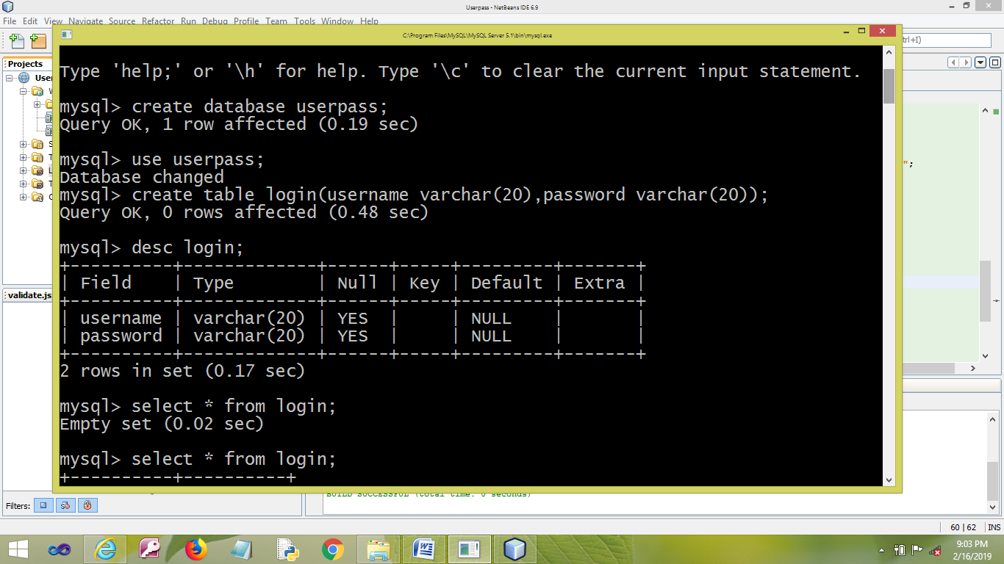

**NETBEANS**

**index.jsp**

<html>

<head>

<meta http-equiv="Content-Type" content="text/html; charset=UTF-8">

<title>LOGIN</title>

</head>

<body>

<form method="post" action="validate.jsp">

<center>

<table border="1" cellpadding="5" cellspacing="2">

<thead>

<tr>

<th colspan="2">CLICK HERE TO LOGIN</th>

</tr>

</thead>

<tbody>

<tr>

<td>USERNAME</td>

<td><input type="text" name="usernamee" required/></td>

</tr>

<tr>

<td>PASSWORD</td>

<td><input type="password" name="passwordd" required/></td>

</tr>

<tr>

<td colspan="2" align="center"><input type="submit" name="action" value="LOGIN" />

&nbsp;&nbsp;

<input type="submit" name="action" value="INSERT" />

<input type="submit" name="action" value="DELETE" />

<input type="submit" name="action" value="UPDATE" />

<input type="submit" name="action" value="VIEW" />

</td>

</tr>

</tbody>

</table>

</center>

</form>

</body>

</html>

**validate.jsp**

<%@ page import ="java.sql.*" %>

<%

try

{

String u = request.getParameter("usernamee");

String p = request.getParameter("passwordd");

String a=request.getParameter("action");

Class.forName("com.mysql.jdbc.Driver");

Connection conn = DriverManager.getConnection("jdbc:mysql://localhost:3306/userpass","root","mysql");

if (a.equals("LOGIN"))

{

String query =" SELECT * FROM login where username='"+u+"' and password='"+p+"'";

Statement stat = null;

stat = conn.createStatement();

ResultSet rs=stat.executeQuery(query);

if(rs.next())

{

out.println("LOGIN SUCCESSFULLY.......");

out.newLine();

out.println("YOU ARE WELCOME");

}

else

out.println("Invalid LOGIN..... PLEASE TRY AGAIN");

}

else if (a.equals("INSERT"))

{

out.println("INSERTED SUCCESSFULLY");

String query =" insert into login values "+"('"+u+"','"+p+"')";

Statement stat = null;

stat = conn.createStatement();

stat.executeUpdate(query);

}

else if (a.equals("DELETE"))

{

out.println("DELETED SUCCESSFULLY");

String query =" delete from login where username='"+u+"' and password='"+p+"'";

Statement stat = null;

stat = conn.createStatement();

stat.executeUpdate(query);

}

else if (a.equals("UPDATE"))

{

out.println("UPDATED SUCCESSFULLY");

String query ="update login set password ='"+p+"' where username='"+u+"'";

Statement stat = null;

stat = conn.createStatement();

stat.executeUpdate(query);

}

else if(a.equals("VIEW"))

{

String query =" SELECT * FROM login where username='"+u+"' and password='"+p+"'";

Statement stat = null;

stat = conn.createStatement();

ResultSet rs=stat.executeQuery(query);

if(rs.next())

{

out.println("YOU HAVE AN ACCOUNT");

}

else

out.println("SORRY.......PLEASE TRY AGAIN");

}

}

catch(Exception e)

{

out.println(e.toString());

}

%>

**OUTPUT**

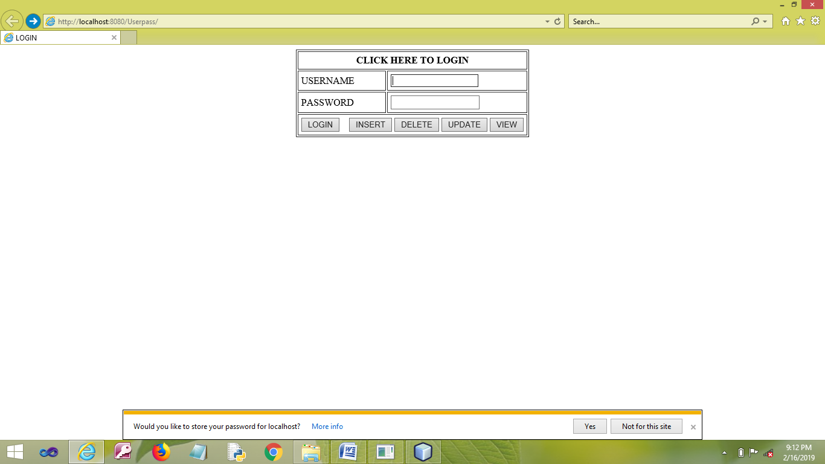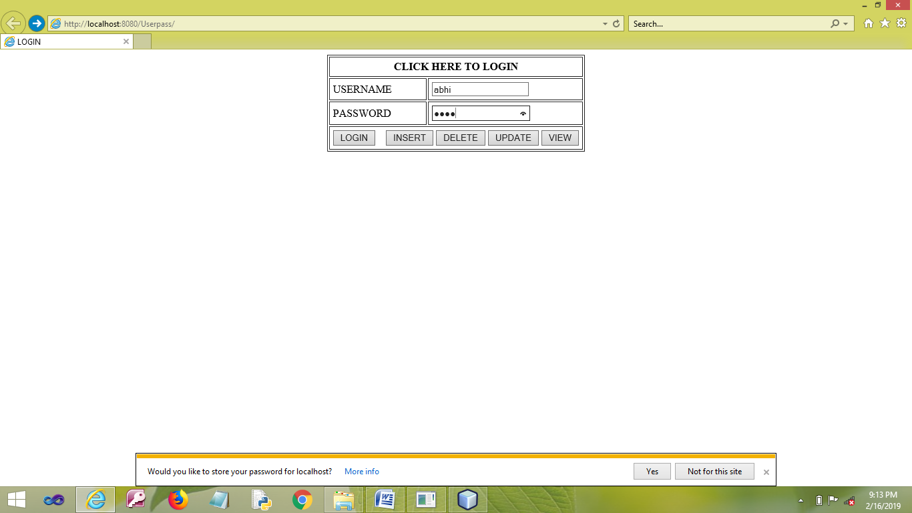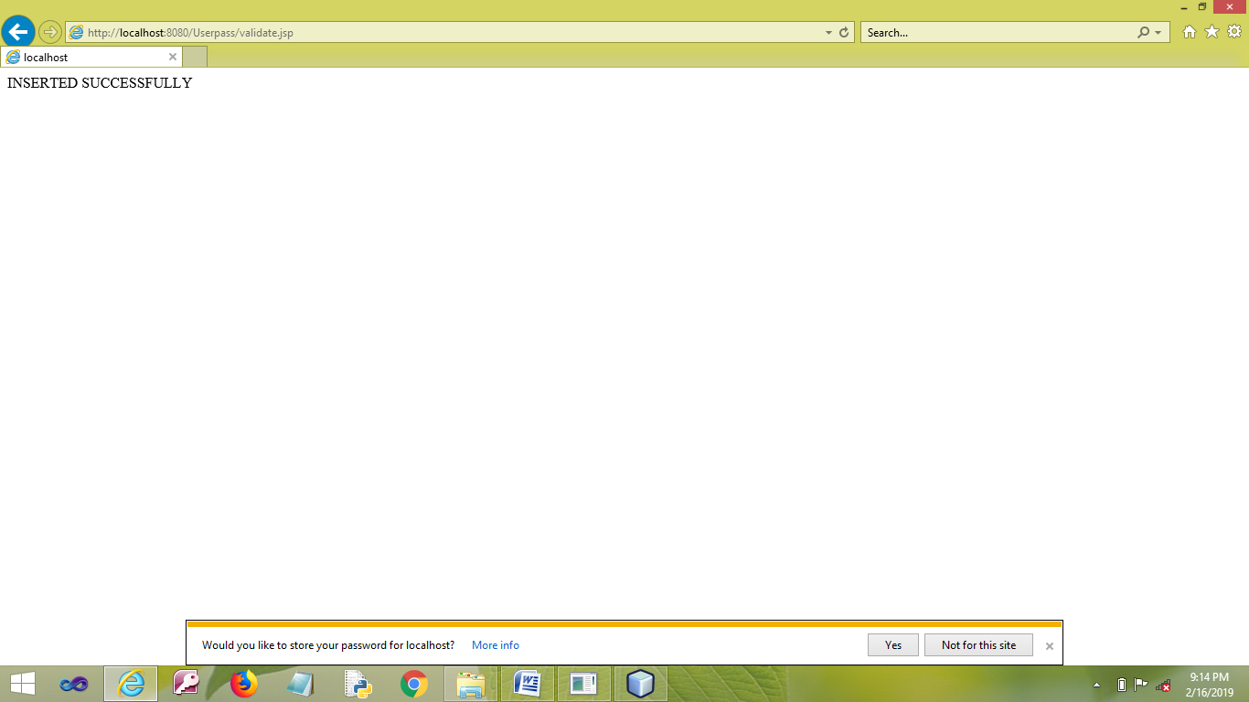

**RESULT**

Thus the program has been developed and executed successfully.

|  |  |
| --- | --- |
| EX.NO: **02** | **CAR INVENTORY USING JSP AND JDBC** |
| DATE: |

**AIM**

To develop a Car Showroom Inventory Web Application using JSP and JDBC.

**PROCEDURE**

**MYSQL**

* Open MYSQL.
* Create Database and Table.

**NETBEANS**

* Open NetBeans IDE 6.9
* Open File →New Project.
* Choose Java Web →Web Application.
* Next.
* Give the Project a Name.
* Next →Next→Finish.
* Write Coding for **index.jsp** File.
* Right click on the Web Page of your Project.
* Select New →JSP.
* Give the File Name as **validate**.
* Write coding for the Validation and to connect with MYSQL on the **validate.jsp** File.
* Finish.
* Right Click on the Libraries.
* Select Add Library … → MySQL JDBC Driver.
* Click Add Library.
* Save the Project.
* Run the Project.

**PROGRAM**

**MYSQL**

* create database **carinventory**;
* use **carinventory**;
* create table **carcustomer**(id varchar(10),name varchar(20),quantity varchar(5),price varchar(10));

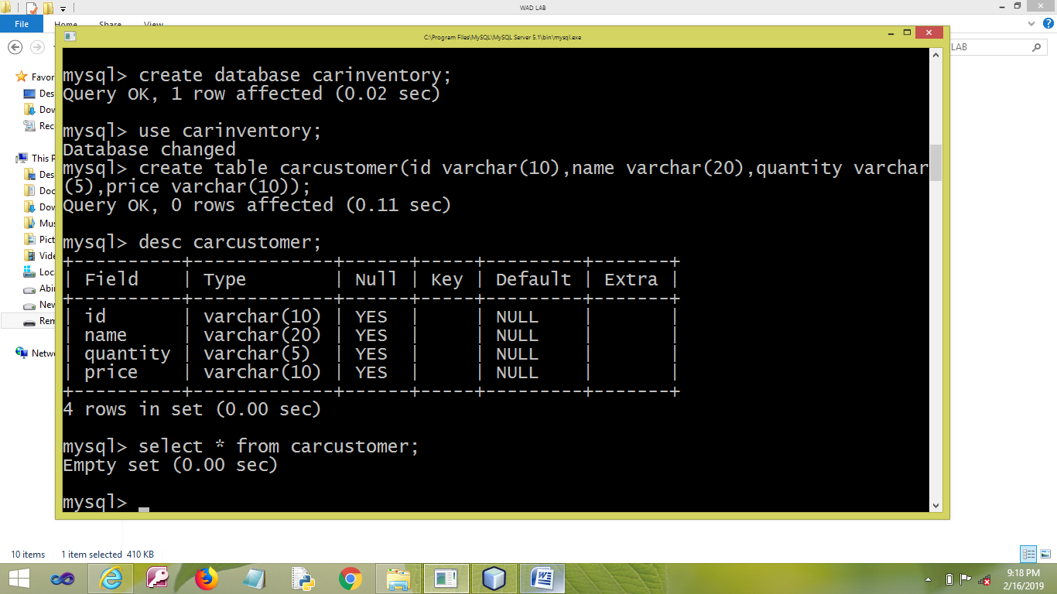

**NETBEANS**

**index.jsp**

<html>

<head>

<meta http-equiv="Content-Type" content="text/html; charset=UTF-8">

<title>Car</title>

</head>

<body>

<form method="post" action="validate.jsp">

<center>

<table border="1" cellpadding="5" cellspacing="2">

<thead>

<tr>

<th colspan="3">CLICK HERE FOR CAR DETAILS</th>

</tr>

</thead>

<tbody>

<tr>

<td>ID</td>

<td><input type="text" name="id" required/></td>

<td><input type="submit" name="action" value="INSERT" /></td>

</tr>

<tr>

<td>NAME</td>

<td><input type="text" name="name" required/></td>

<td> <input type="submit" name="action" value="DELETE" /></td>

</tr>

<tr>

<td>QUANTITY</td>

<td><input type="text" name="quantity" required/></td>

<td><input type="submit" name="action" value="UPDATE" /></td>

</tr>

<tr>

<td>PRICE</td>

<td><input type="text" name="price" required/></td>

<td><input type="submit" name="action" value="VIEW" /></td>

</tr>

</tbody>

</table>

</center>

</form>

</body>

</html>

**validate.jsp**

<%@ page import ="java.sql.*" %>

<%

try{

String i = request.getParameter("id");

String n = request.getParameter("name");

String q = request.getParameter("quantity");

String p = request.getParameter("price");

String a = request.getParameter("action");

Class.forName("com.mysql.jdbc.Driver");

Connection conn = DriverManager.getConnection("jdbc:mysql://localhost:3306/carinventory","root","mysql");

if (a.equals("VIEW"))

{

String query =" SELECT * FROM carcustomer where id='"+i+"' and name='"+n+"' and quantity='"+q+"' and price='"+p+"'";

Statement stat = null;

stat = conn.createStatement();

ResultSet rs=stat.executeQuery(query);

if(rs.next())

out.println("WELCOME.....Car Holder");

else

out.println("Sorry......Check Details");

}

else if (a.equals("INSERT"))

{

out.println("INSERTED SUCCESSFULLY");

String query =" insert into carcustomer values "+"('"+i+"','"+n+"','"+q+"','"+p+"')";

Statement stat = null;

stat = conn.createStatement();

stat.executeUpdate(query);

}

else if (a.equals("DELETE"))

{

out.println("DELETED SUCCESSFULLY");

String query =" delete from carcustomer where id='"+i+"' and name='"+n+"' and quantity='"+q+"' and price='"+p+"'";

Statement stat = null;

stat = conn.createStatement();

stat.executeUpdate(query);

}

else if (a.equals("UPDATE"))

{

out.println("UPDATED SUCCESSFULLY");

String query ="update carcustomer set id ='"+i+"' where name='"+n+"' and quantity='"+q+"' and price='"+p+"'";

Statement stat = null;

stat = conn.createStatement();

stat.executeUpdate(query);

}

}

catch(Exception e){

out.println(e.toString());

}

%>

**OUTPUT**

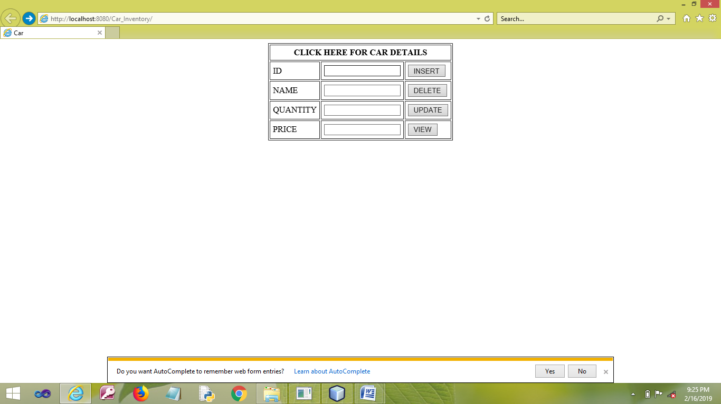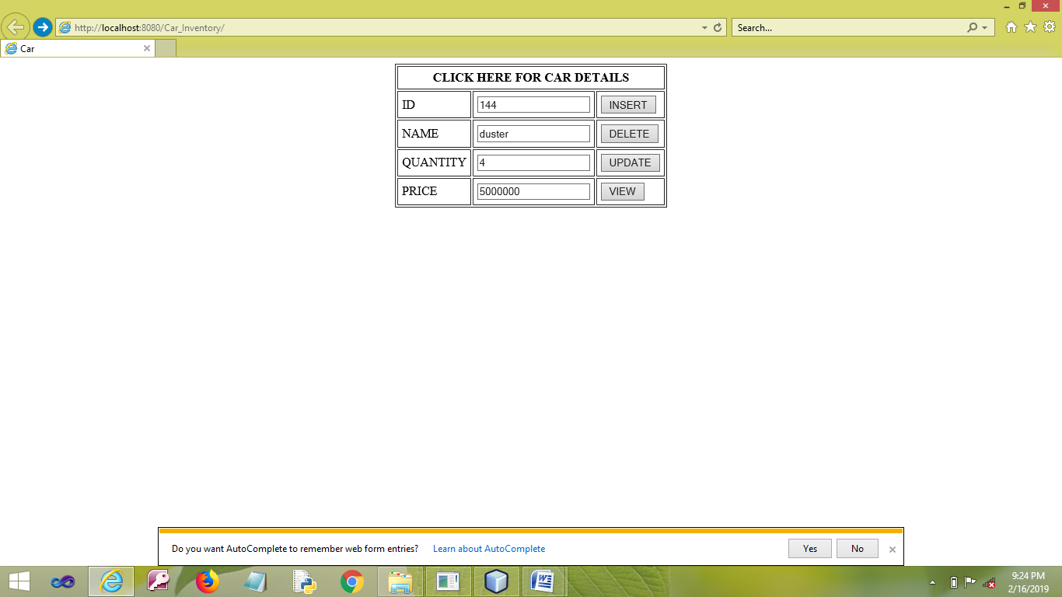

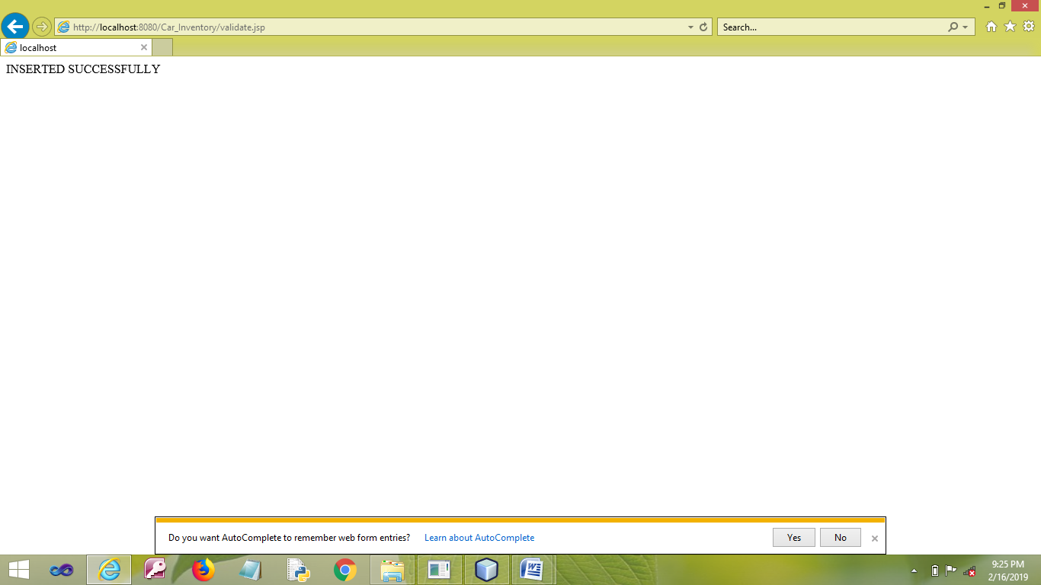

**RESULT**

Thus the program has been developed and executed successfully.

|  |  |
| --- | --- |
| EX.NO: **03** | **REAL ESTATE USING JSP AND JDBC** |
| DATE: |

**AIM**

To develop a Web Application for a Real Estate using JSP and JDBC.

**PROCEDURE**

**MYSQL**

* Open MYSQL.
* Create Database and Table.

**NETBEANS**

* Open NetBeans IDE 6.9
* Open File →New Project.
* Choose Java Web →Web Application.
* Next.
* Give the Project a Name.
* Next →Next→Finish.
* Write Coding for **index.jsp** File.
* Right click on the Web Page of your Project.
* Select New →JSP.
* Give the File a Name **validate**.
* Write coding for the Validation and to connect with MYSQL on the **validate.jsp**.
* Finish.
* Right Click on the Libraries.
* Select Add Library … → MySQL JDBC Driver.
* Click Add Library.
* Save the Project.
* Run the Project.

**PROGRAM**

**MYSQL**

* create database **realestate**;
* use **realestate**;
* create table **estate**(doorno varchar(5),area varchar(15),amount varchar(10),owner varchar(20),contactnumber varchar(10));

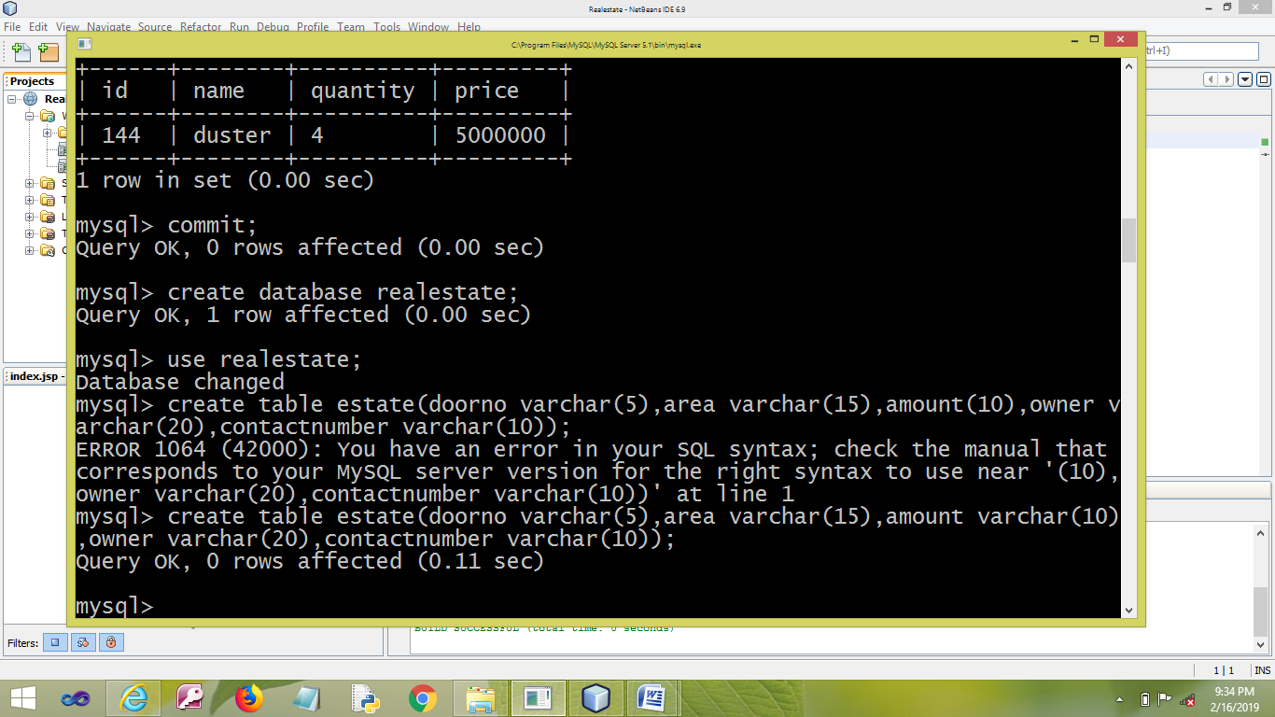

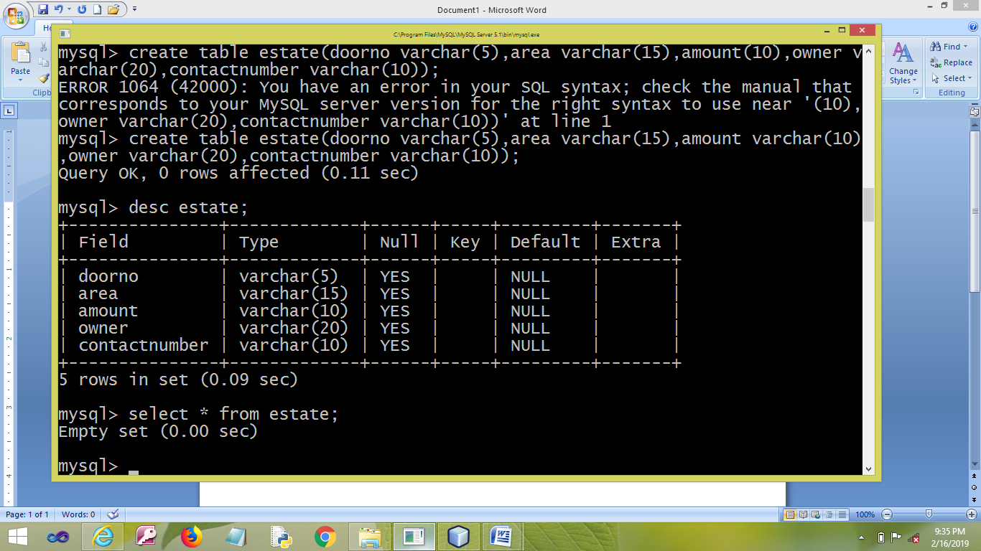

**NETBEANS**

**index.jsp**

<html>

<head>

<meta http-equiv="Content-Type" content="text/html; charset=UTF-8">

<title>REAL ESTATE</title>

</head>

<body>

<form method="post" action="validate.jsp">

<center>

<table border="1" cellpadding="5" cellspacing="2">

<thead>

<tr>

<th colspan="2">DETAILS</th>

</tr>

</thead>

<tbody>

<tr>

<td>DOOR NO.</td>

<td><input type="text" name="doorno" required/></td>

</tr>

<tr>

<td>AREA</td>

<td><input type="text" name="area" required/></td>

</tr>

<tr>

<td>PROPERTY TYPE</td>

<td><select name="property">

<option value="individual/rental">individual/rental</option>

<option value="apartment/rental">apartment/rental</option>

<option value="individual/own">individual/own</option>

<option value="apartment/own">apartment/own</option>

<option value="apartment/own" selected>--CHOOSE---</option>

</select>

</tr>

<tr>

<td>AMOUNT</td>

<td><input type="text" name="amount" required/></td>

</tr>

<tr>

<td>OWNER</td>

<td><input type="text" name="owner" required/></td>

</tr>

<tr>

<td>CONTACT NO.</td>

<td><input type="text" name="contactnumber" required/></td>

</tr>

<tr>

<td colspan="2" align="center">

<input type="submit" name="action" value="INSERT" />

<input type="submit" name="action" value="DELETE" />

<input type="submit" name="action" value="UPDATE" />

<input type="submit" name="action" value="VIEW" />

</td>

</tr>

</tbody>

</table>

</center>

</form>

</body>

</html>

**validate.jsp**

<%@ page import ="java.sql.*" %>

<%

try{

String d = request.getParameter("doorno");

String ar = request.getParameter("area");

String am=request.getParameter("amount");

String o=request.getParameter("owner");

String c=request.getParameter("contactnumber");

String a=request.getParameter("action");

Class.forName("com.mysql.jdbc.Driver");

Connection conn = DriverManager.getConnection("jdbc:mysql://localhost:3306/realestate","root","mysql");

if (a.equals("VIEW"))

{

String query =" SELECT * FROM estate where doorno='"+d+"' and area='"+ar+"' and amount='"+am+"' and owner='"+o+"' and contactnumber='"+c+"'";

Statement stat = null;

stat = conn.createStatement();

ResultSet rs=stat.executeQuery(query);

if(rs.next())

{

out.println("WELCOME<br>");

out.println("YOU ARE A MEMBER");

}

else

{

out.println("SORRY<br>");

out.println("YOU ARE NOT A MEMBER");

}

}

else if (a.equals("INSERT"))

{

out.println("INSERTED SUCCESSFULLY");

String query =" insert into estate values ('"+d+"','"+ar+"','"+am+"','"+o+"','"+c+"')";

Statement stat = null;

stat = conn.createStatement();

stat.executeUpdate(query);

}

else if (a.equals("DELETE"))

{

out.println("DELETED SUCCESSFULLY");

String query =" delete from estate where doorno='"+d+"' and area='"+ar+"' and amount='"+am+"' and owner='"+o+"' and contactnumber='"+c+"'";

Statement stat = null;

stat = conn.createStatement();

stat.executeUpdate(query);

}

else if (a.equals("UPDATE"))

{

out.println("UPDATED SUCCESSFULLY");

String query ="update estate set doorno ='"+d+"' where area='"+ar+"' and amount='"+am+"' and owner='"+o+"' and contactnumber='"+c+"'";

Statement stat = null;

stat = conn.createStatement();

stat.executeUpdate(query);

}

}

catch(Exception e){

out.println(e.toString());

}

%>

**OUTPUT**

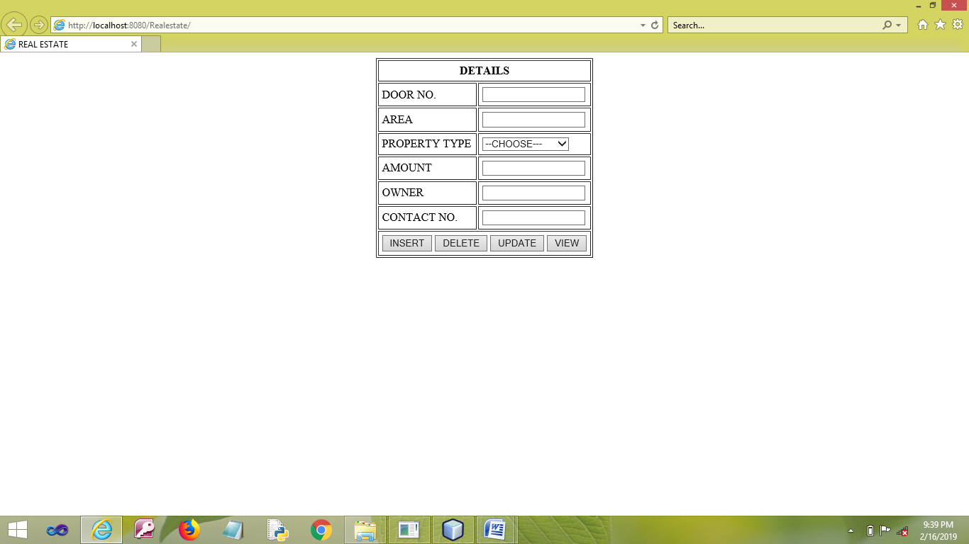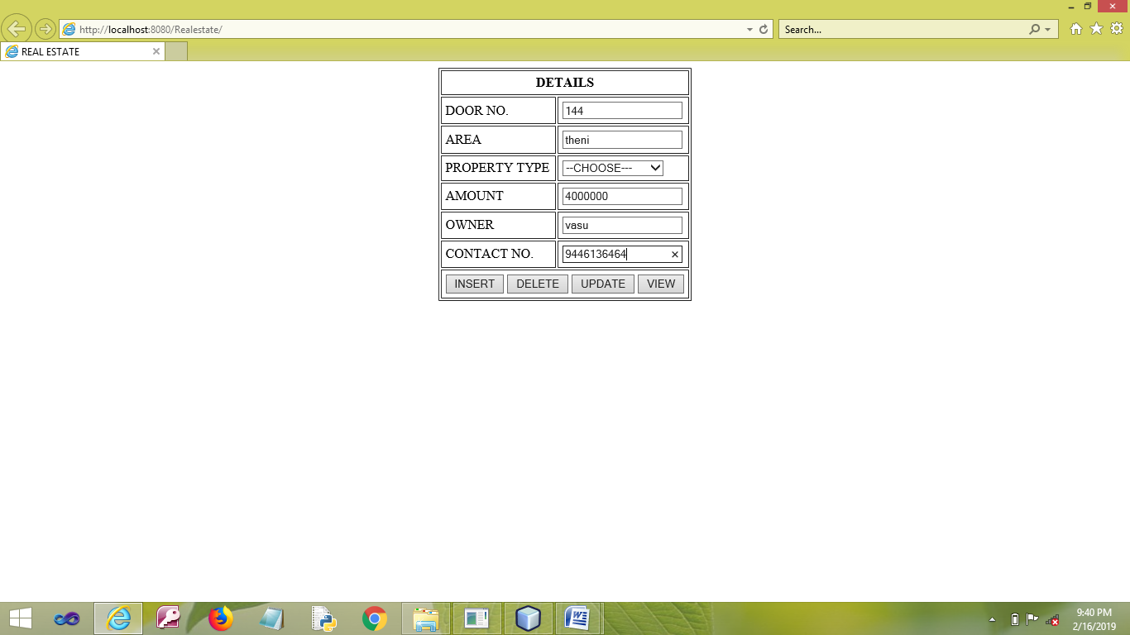

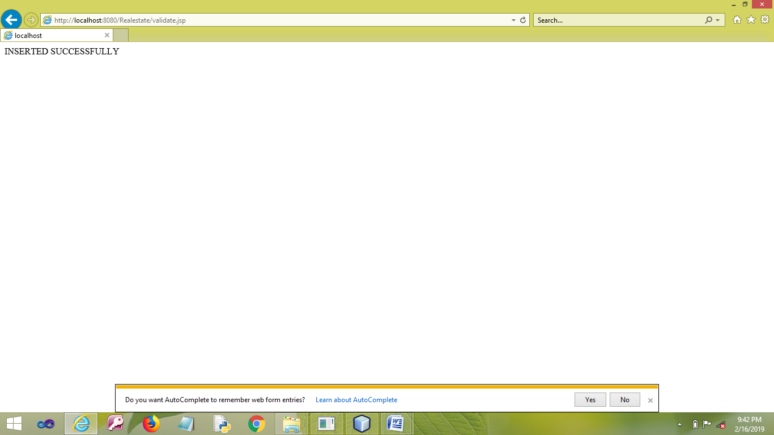

**RESULT**

Thus the program has been developed and executed successfully.

|  |  |
| --- | --- |
| EX.NO: **04** | **USER AUTHENTICATION USING** **LDAP** |
| DATE: |

**AIM**

To develop a Web Application to check the Authentication of an User using LDAP.

**PROCEDURE**

**NETBEANS**

* Open NetBeans IDE 6.9
* Open File →New Project.
* Choose Java Web →Web Application.
* Next.
* Give the Project a Name.
* Next →Next→Finish.
* Write Coding for **index.jsp** File.
* Right click on the Web Page of your Project.
* Select New →JSP.
* Give the File a Name **response**.
* Write coding for the Validation and to connect with MYSQL on the **response.jsp** File.
* Finish.
* Right Click on the Libraries.
* Select Add Library … → MySQL JDBC Driver.
* Click Add Library.
* Save the Project.
* Run the Project.

**PROGRAM**

**NETBEANS**

**index.jsp**

<html>

<head>

<meta http-equiv="Content-Type" content="text/html; charset=UTF-8">

<title>LDAP</title>

</head>

<body>

<form method="post" action="response.jsp">

<center>

<table border="1" cellpadding="5" cellspacing="2">

<thead>

<tr>

<th colspan="2">LDAP</th>

</tr>

</thead>

<tbody>

<tr>

<td>USERNAME</td>

<td><input type="text" name="usernamee" required/></td>

</tr>

<tr>

<td>PASSWORD</td>

<td><input type="password" name="passwordd" required/></td>

</tr>

<tr>

<td colspan="2" align="center"><input type="submit" name="action" value="SUBMIT" />

</td>

</tr>

</tbody>

</table>

</center>

</form>

</body>

</html>

**response.jsp**

<%@page import="java.util.Hashtable"%>

<%@page import="javax.naming.*"%>

<%@page import=" javax.naming.directory.*"%>

<%

String id=request.getParameter("usernamee");

String pwd=request.getParameter("passwordd");

String LDAP_SERVER_URL = "ldap://ldap.forumsys.com:389";

String USER_CONTEXT = "dc=example,dc=com";

DirContext ctx = null;

try

{

Hashtable<String, String> env = new Hashtable<String, String>();

env.put(Context.INITIAL_CONTEXT_FACTORY, "com.sun.jndi.ldap.LdapCtxFactory");

env.put(Context.PROVIDER_URL, LDAP_SERVER_URL);

env.put(Context.SECURITY_AUTHENTICATION, "simple");

env.put(Context.SECURITY_PRINCIPAL, "uid=" + id + "," + USER_CONTEXT);

env.put(Context.SECURITY_CREDENTIALS,pwd);

ctx = new InitialDirContext(env);

out.println("You are a Valid User<br><br>");

}

catch (NamingException e)

{

out.println(“Invalid User”);

}

%>

**OUTPUT**

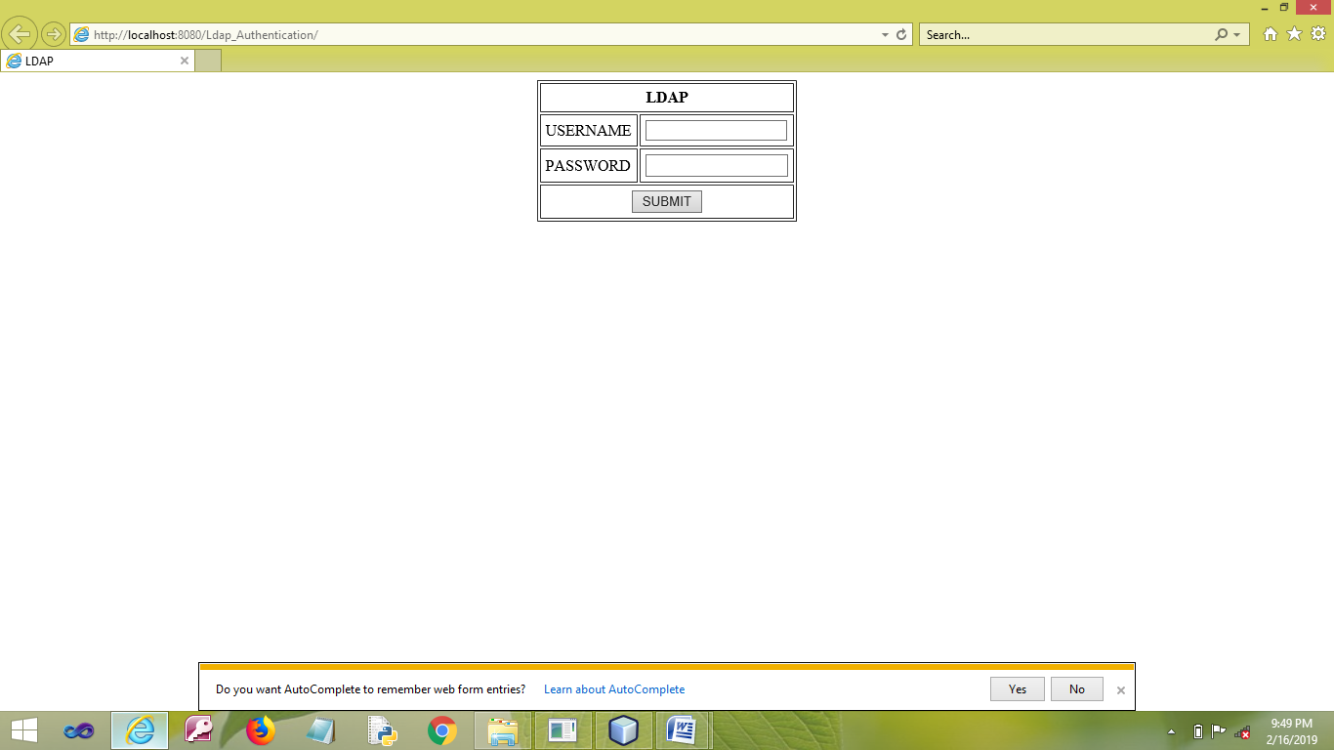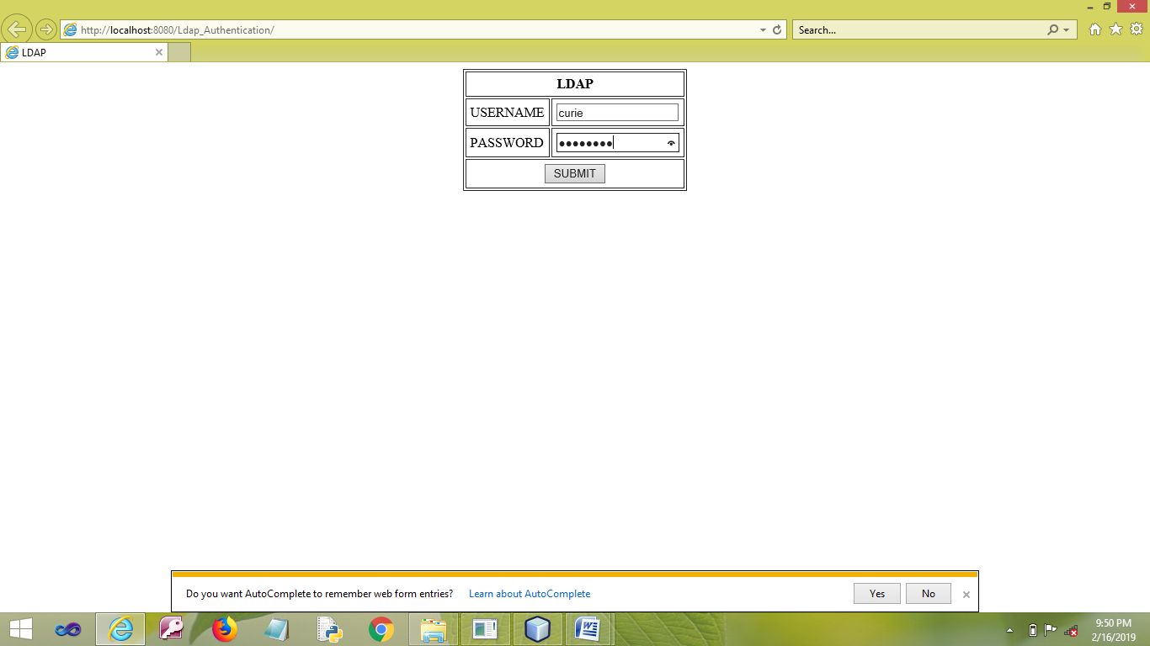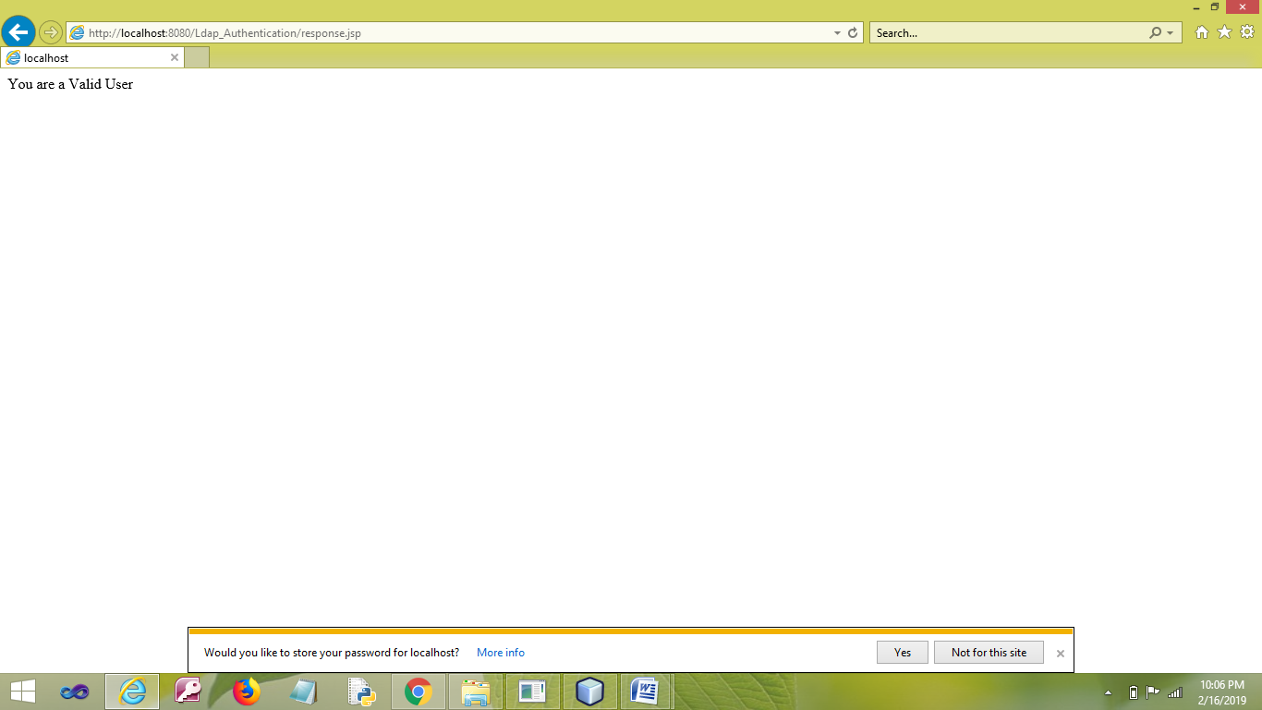

**RESULT**

Thus the program has been developed and executed successfully.

|  |  |
| --- | --- |
| EX.NO: **05** | **RETRIEVE USER INFORMATION USING LDAP** |
| DATE: |

**AIM**

To develop a Web Application to display the Tree Structure of the Authenticated User’s Details using LDAP.

**PROCEDURE**

**NETBEANS**

* Open NetBeans IDE 6.9
* Open File →New Project.
* Choose Java Web →Web Application.
* Next.
* Give the Project a Name.
* Next →Next→Finish.
* Write **index.jsp** File Coding.
* Right click on the Web Page of your Project.
* Select New →JSP.
* Give the File a Name **response**.
* Write coding for the Validation and to connect with MYSQL on the **response.jsp** File.
* Finish.
* Right Click on the Libraries.
* Select Add Library … → MySQL JDBC Driver.
* Click Add Library.
* Save the Project.
* Run the Project.

**PROGRAM**

**index.jsp**

<html>

<head>

<meta http-equiv="Content-Type" content="text/html; charset=UTF-8">

<title>LDAP</title>

</head>

<body>

<form method="post" action="response.jsp">

<center>

<table border="1" cellpadding="5" cellspacing="2">

<thead>

<tr>

<th colspan="2">LDAP</th>

</tr>

</thead>

<tbody>

<tr>

<td>USERNAME</td>

<td><input type="text" name="usernamee" required/></td>

</tr>

<tr>

<td>PASSWORD</td>

<td><input type="password" name="passwordd" required/></td>

</tr>

<tr>

<td colspan="2" align="center"><input type="submit" name="action" value="SUBMIT" />

</td>

</tr>

</tbody>

</table>

</center>

</form>

</body>

</html>

**response.jsp**

<%@page import="java.util.Hashtable"%>

<%@page import="javax.naming.*"%>

<%@page import=" javax.naming.directory.*"%>

<%

String id=request.getParameter("usernamee");

String pwd=request.getParameter("passwordd");

String LDAP_SERVER_URL = "ldap://ldap.forumsys.com:389";

String USER_CONTEXT = "dc=example,dc=com";

DirContext ctx = null;

try

{

Hashtable<String, String> env = new Hashtable<String, String>();

env.put(Context.INITIAL_CONTEXT_FACTORY, "com.sun.jndi.ldap.LdapCtxFactory");

env.put(Context.PROVIDER_URL, LDAP_SERVER_URL);

env.put(Context.SECURITY_AUTHENTICATION, "simple");

env.put(Context.SECURITY_PRINCIPAL, "uid=" + id + "," + USER_CONTEXT);

env.put(Context.SECURITY_CREDENTIALS,pwd);

ctx = new InitialDirContext(env);

out.println("WELCOME<br><br>");

SearchControls scs = new SearchControls();

scs.setSearchScope(SearchControls.SUBTREE_SCOPE);

String[] attrNames = {"cn" , "mail" , "sn" };

scs.setReturningAttributes(attrNames);

NamingEnumeration nes = ctx.search(USER_CONTEXT, "uid=" + id, scs);

if(nes.hasMore()) {

Attributes attrs = ((SearchResult) nes.next()).getAttributes();

out.println("<br>COMMON NAME : " + attrs.get("cn").get());

out.println("<br>MAIL ID : " + attrs.get("mail").get());

out.println("<br>SURNAME : " + attrs.get("sn").get());

}

}

catch (NamingException e)

{

out.println("Invalid User");

}

%>

**OUTPUT**



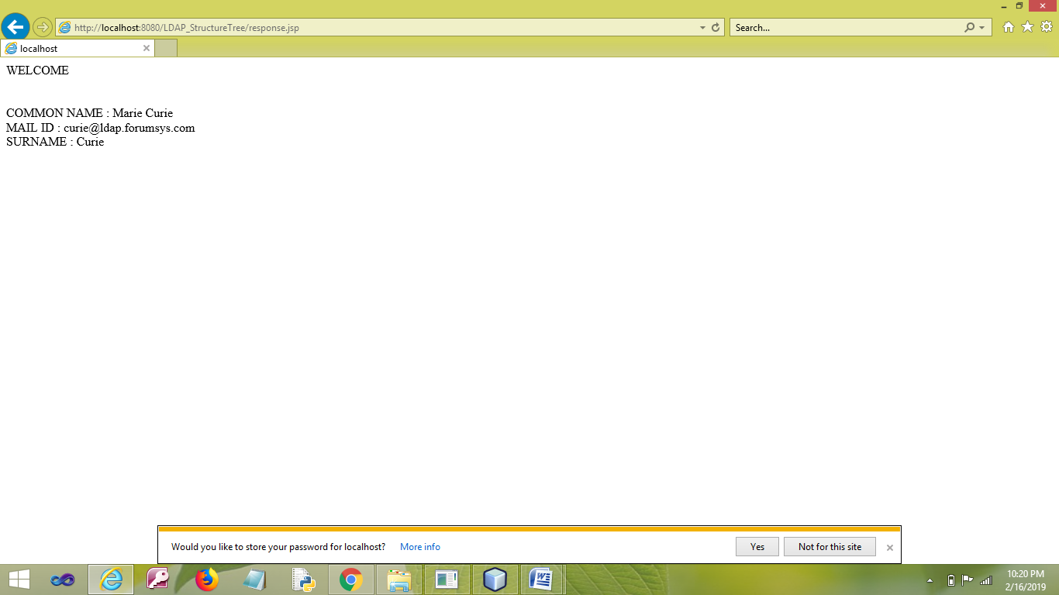

**RESULT**

Thus the program has been developed and executed successfully.

|  |  |
| --- | --- |
| EX.NO: **06** | **LIBRARY MANAGEMENT USING JSP,JDBC AND SERVLET** |
| DATE: |

**AIM**

To develop a Web Application for a Library to manage Books using JSP, JDBC and Servlet.

**PROCEDURE**

**MYSQL**

* Open MYSQL.
* Create Database and Table.

**NETBEANS**

* Open NetBeans IDE 6.9
* Open File →New Project.
* Choose Java Web →Web Application.
* Next.
* Give the Project a Name.
* Next →Next→Finish.
* Write Coding for **index.jsp** File.
* Right click on the Source Package.
* Select Servlet.
* Give the Java File a Name.
* Choose the option **Add information to deployment descriptor(web.xml)**.
* Finish.
* Right click on the Web Page of your Project.
* Select New →JSP.
* Give the File a Name **welcome**.
* Write coding for the success page on the **welcome.jsp** File.
* Finish
* Right click on the Web Page of your Project.
* Select New →JSP.
* Give the File a Name **fail**.
* Write coding for the success page on the **fail.jsp** File.
* Finish.
* Right Click on the Libraries.
* Select Add Library … → MySQL JDBC Driver.
* Click Add Library.
* Save the Project.
* Run the Project.

**PROGRAM**

**MYSQL**

* create database **library**;
* use **library**;
* create table **lib**(bookno varchar(10),bookname varchar(20),author varchar(20),date varchar(15),price varchar(8));

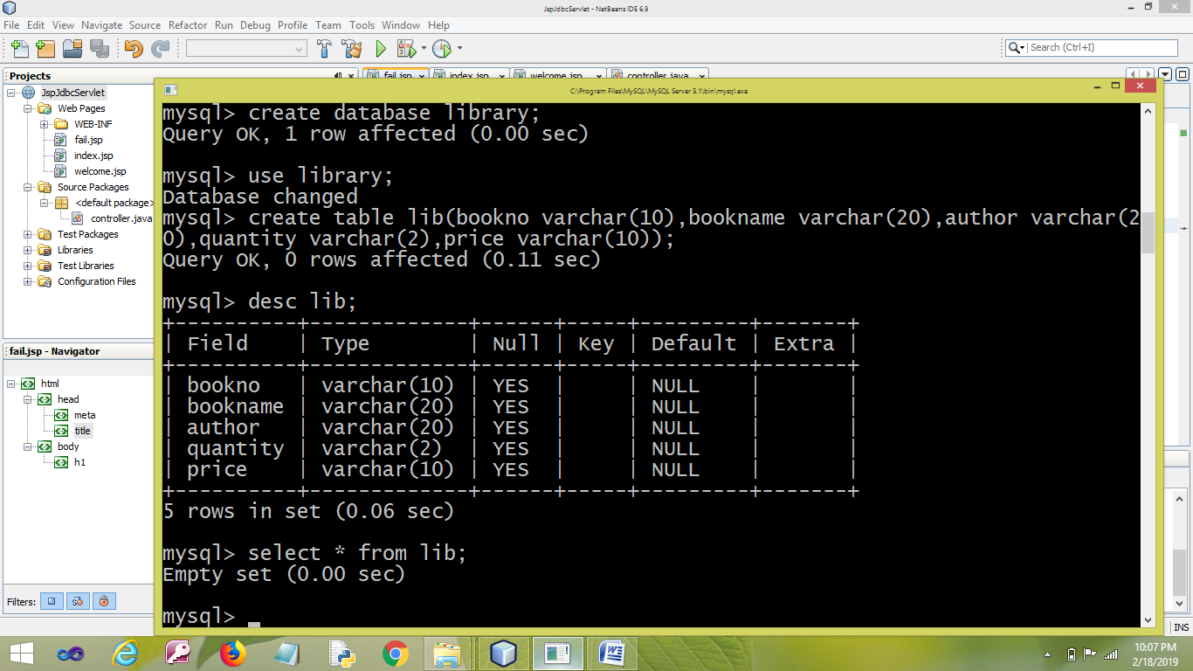

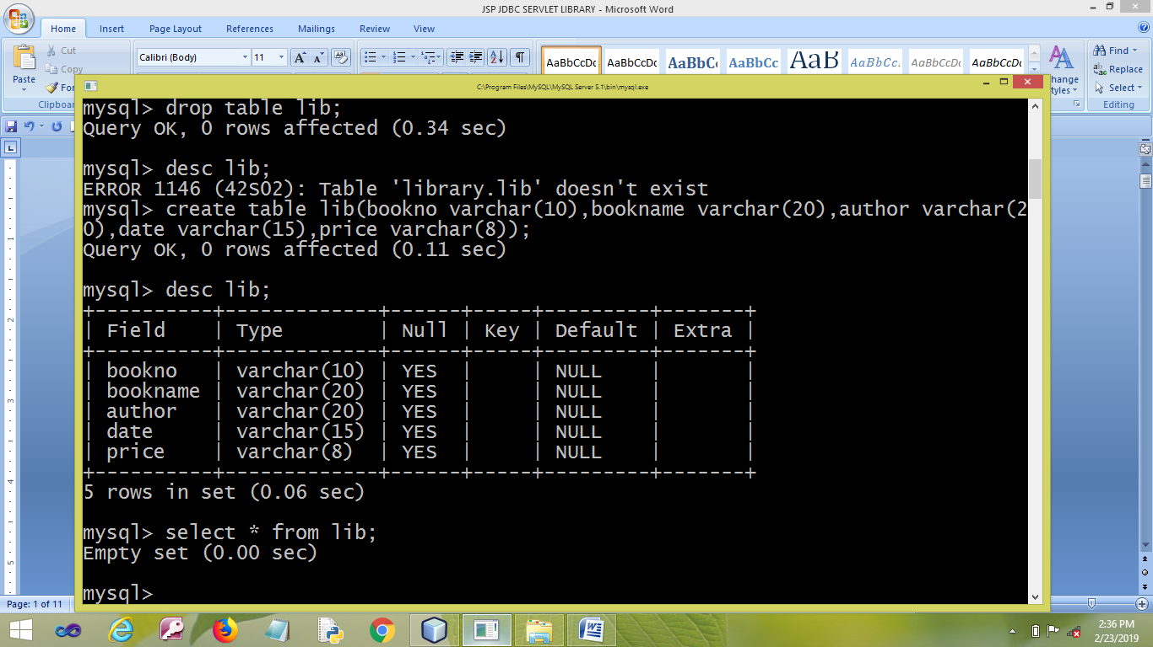

**NETBEANS**

**index.jsp**

<%@page contentType="text/html" pageEncoding="UTF-8"%>

<!DOCTYPE HTML PUBLIC "-//W3C//DTD HTML 4.01 Transitional//EN"

"http://www.w3.org/TR/html4/loose.dtd">

<html>

<head>

<meta http-equiv="Content-Type" content="text/html; charset=UTF-8">

<title>LIBRARY</title>

</head>

<body>

<h1 align="center">DETAILS</h1>

<form action="controller" method="POST" target="_blank">

<center>

<table>

<tr>

<td><label for="bkno"><b>BOOK NO.</b></label></td>

<td><input type="text" placeholder="Enter Book No." name="bkno" required> </td>

</tr>

<tr>

<td><label for="bknm"><b>BOOK NAME</b></label></td>

<td><input type="text" placeholder="Enter Book Name" name="bknm" required></td>

</tr>

<tr>

<td><label for="ath"><b>AUTHOR</b></label></td>

<td><input type="text" placeholder="Enter Author" name="ath" required> </td>

</tr>

<tr>

<td><label for="d"><b>DATE</b></label></td>

<td><input type="text" placeholder="Enter Date" name="d" required> </td>

</tr>

<tr>

<td><label for="pc"><b>PRICE</b></label></td>

<td><input type="text" placeholder="Enter Price" name="pc" required> </td>

</tr>

<tr>

<td colspan="2"> <button type="submit" name="insert">ISSUE</button>

<button type="submit" name="update" >EXTEND</button>

<button type="submit" name="delete" >RETURN</button>

<button type="submit" name="view" >VIEW</button>

</td>

</tr>

</table>

</center>

</form>

</body>

</html>

**controller.java(SERVLET FILE)**

import java.io.IOException;

import java.io.PrintWriter;

import javax.servlet.ServletException;

import javax.servlet.http.HttpServlet;

import javax.servlet.http.HttpServletRequest;

import javax.servlet.http.HttpServletResponse;

import java.sql.*;

public class controller extends HttpServlet {

protected void processRequest(HttpServletRequest request, HttpServletResponse response)

throws ServletException, IOException {

response.setContentType("text/html;charset=UTF-8");

PrintWriter out = response.getWriter();

try {

String bno=request.getParameter("bkno") ;

String bnm=request.getParameter("bknm") ;

String auth=request.getParameter("ath");

String dt=request.getParameter("d");

String prc=request.getParameter("pc");

Class.forName("com.mysql.jdbc.Driver");

Connection con = DriverManager.getConnection("jdbc:mysql://localhost:3306/library","root","mysql");

Statement stat = null;

stat = con.createStatement();

ResultSet rs ;

if (request.getParameter("insert") != null) {

String query ="insert into lib values('"+bno+"','"+bnm+"','"+auth+"','"+dt+"','"+prc+"')";

stat.executeUpdate(query);

out.println("YOUR BOOK IS BEEN ISSUED");

} else if (request.getParameter("update") != null) {

String query1="select * from lib where bookno='"+bno+"'";

rs=stat.executeQuery(query1);

if (rs.next())

{

String query ="update lib set date='"+dt+"' where bookno='"+bno+"' and bookname='"+bnm+"' and author='"+auth+"' and price='"+prc+"' ";

stat.executeUpdate(query);

}

out.println("YOUR ISSUE OF BOOK HAVE BEEN EXTENDED");

}

else if (request.getParameter("delete") != null) {

String query ="delete from lib where bookno='"+bno+"'";

stat.executeUpdate(query);

out.println("BOOK ISSUED TO YOU HAVE BEEN RETURNED");

}else if (request.getParameter("view") != null) {

int f=0;

String query1="select * from lib where bookno='"+bno+"' and bookname='"+bnm+"' and author='"+auth+"' and date='"+dt+"' and price='"+prc+"'";

rs=stat.executeQuery(query1);

request.setAttribute("name",bnm );

if (rs.next())

{

f=1;

}

if (f==1)

{

request.getRequestDispatcher("welcome.jsp").forward(request, response);

response.sendRedirect("welcome.jsp");

}

else

{

request.getRequestDispatcher("fail.jsp").forward(request, response);

response.sendRedirect("fail.jsp");

}

}

}catch(Exception ex){

out.println(ex.toString());

}

}

// <editor-fold defaultstate="collapsed" desc="HttpServlet methods. Click on the + sign on the left to edit the code.">

/**

* Handles the HTTP <code>GET</code> method.

* @param request servlet request

* @param response servlet response

* @throws ServletException if a servlet-specific error occurs

* @throws IOException if an I/O error occurs

*/

@Override

protected void doGet(HttpServletRequest request, HttpServletResponse response)

throws ServletException, IOException {

processRequest(request, response);

}

/**

* Handles the HTTP <code>POST</code> method.

* @param request servlet request

* @param response servlet response

* @throws ServletException if a servlet-specific error occurs

* @throws IOException if an I/O error occurs

*/

@Override

protected void doPost(HttpServletRequest request, HttpServletResponse response)

throws ServletException, IOException {

processRequest(request, response);

}

/**

* Returns a short description of the servlet.

* @return a String containing servlet description

*/

@Override

public String getServletInfo() {

return "Short description";

}// </editor-fold>

}

**welcome.jsp**

<%@page contentType="text/html" pageEncoding="UTF-8"%>

<!DOCTYPE HTML PUBLIC "-//W3C//DTD HTML 4.01 Transitional//EN"

"http://www.w3.org/TR/html4/loose.dtd">

<html>

<head>

<meta http-equiv="Content-Type" content="text/html; charset=UTF-8">

<title>WELCOME</title>

</head>

<body>

<h1> WELCOME , YOU HOLD A BOOK NAMED ${name} </h1>

</body>

</html>

**fail.jsp**

<%@page contentType="text/html" pageEncoding="UTF-8"%>

<!DOCTYPE html>

<html>

<head>

<meta http-equiv="Content-Type" content="text/html; charset=UTF-8">

<title>FAIL</title>

</head>

<body>

<h1> YOU DON'T HAVE A BOOK </h1>

</body>

</html>

**OUTPUT**

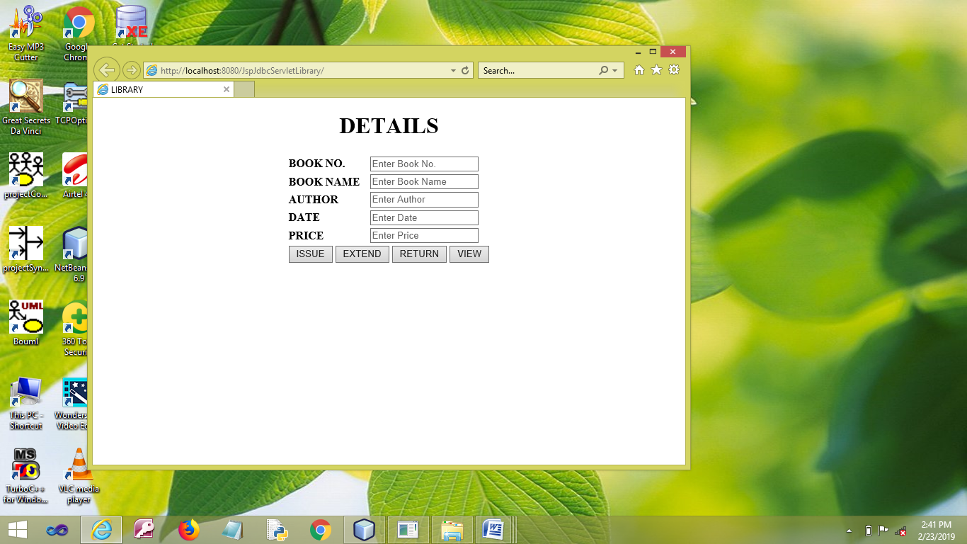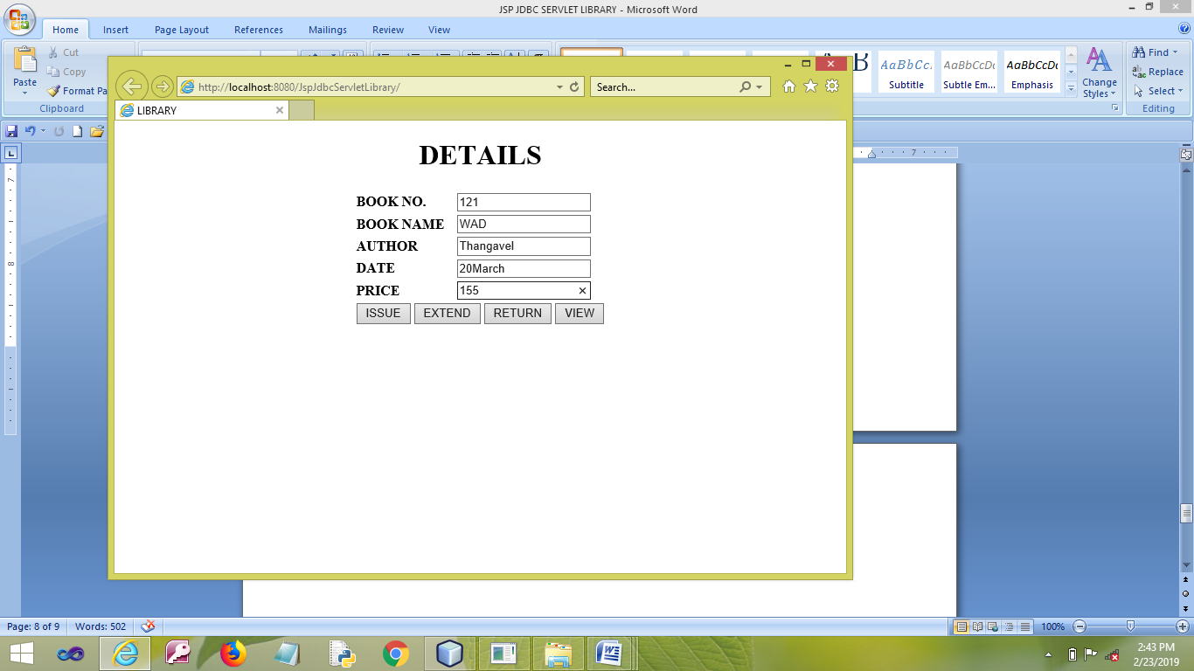

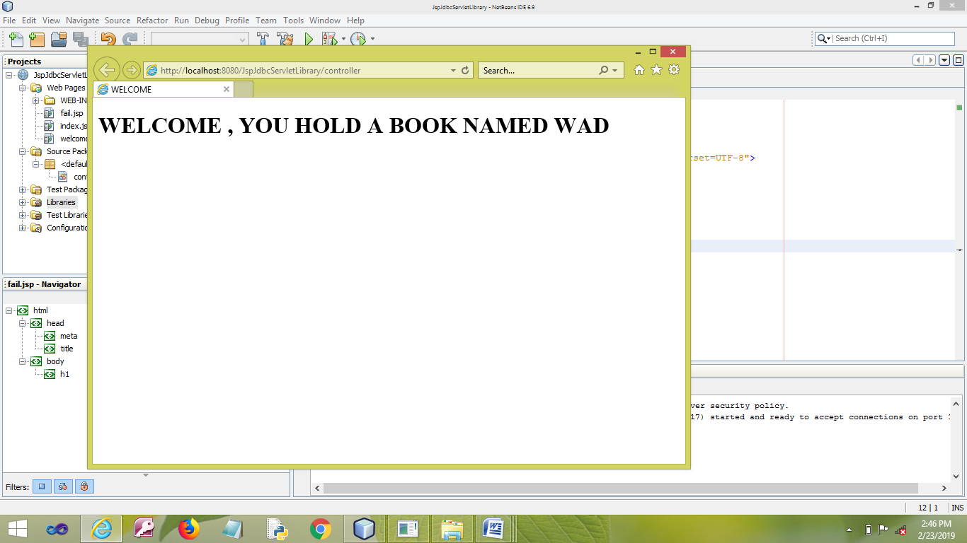

**RESULT**

Thus the program has been developed and executed successfully.

|  |  |
| --- | --- |
| EX.NO: **07** | **RAILWAY RESERVATION USING JSP,JBDC AND SERVLET** |
| DATE: |

**AIM**

To develop a Web Application for Railway Reservation using JSP , JDBC and Servlet.

**PROCEDURE**

**MYSQL**

* Open MYSQL.
* Create Database and Table.

**NETBEANS**

* Open NetBeans IDE 6.9
* Open File →New Project.
* Choose Java Web →Web Application.
* Next.
* Give the Project a Name.
* Next →Next→Finish.
* Write Coding for **index.jsp** File.
* Right click on the Source Package.
* Select Servlet.
* Give the Java File a Name.
* Choose the option **Add information to deployment descriptor(web.xml)**.
* Finish.
* Right click on the Web Page of your Project.
* Select New →JSP.
* Give the File a Name **welcome**.
* Write coding for the success page on the **welcome.jsp** File.
* Finish
* Right click on the Web Page of your Project.
* Select New →JSP.
* Give the File a Name **fail**.
* Write coding for the success page on the **fail.jsp** File.
* Finish.
* Right Click on the Libraries.
* Select Add Library … → MySQL JDBC Driver.
* Click Add Library.
* Save the Project.
* Run the Project.

**PROGRAM**

**MYSQL**

* create database **library**;
* use **library**;
* create table **lib**(bookno varchar(10),bookname varchar(20),author varchar(20),date varchar(15),price varchar(8));

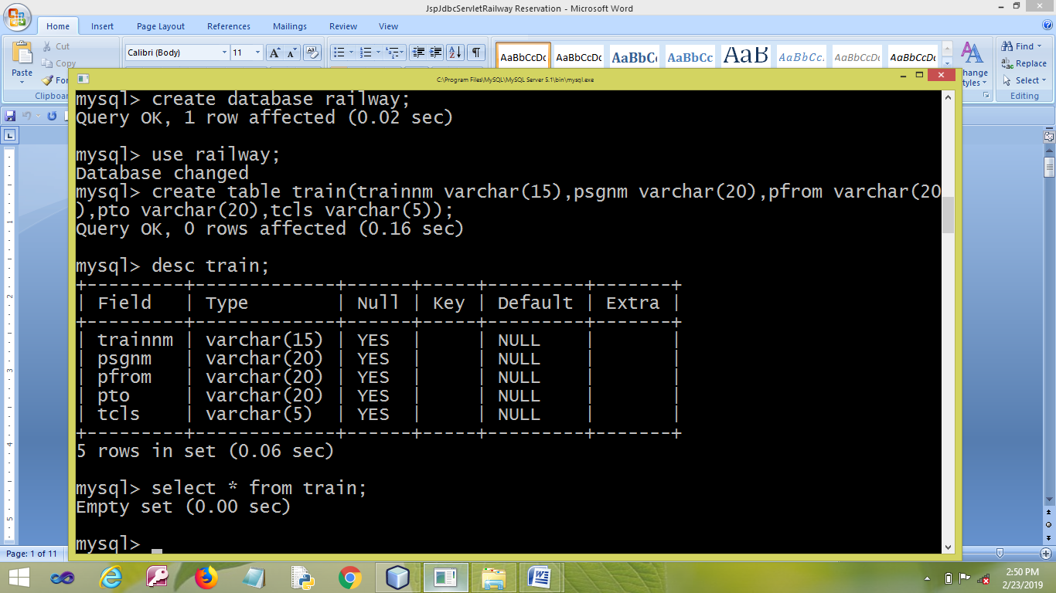

**NETBEANS**

**index.jsp**

<%@page contentType="text/html" pageEncoding="UTF-8"%>

<!DOCTYPE HTML PUBLIC "-//W3C//DTD HTML 4.01 Transitional//EN"

"http://www.w3.org/TR/html4/loose.dtd">

<html>

<head>

<meta http-equiv="Content-Type" content="text/html; charset=UTF-8">

<title>RAILWAY</title>

</head>

<body>

<h1 align="center">RAILWAY RESERVATION</h1>

<form action="controller" method="POST" target="_blank">

<center>

<table>

<tr>

<td><label for="trn"><b>TRAIN NAME</b></label></td>

<td><input type="text" placeholder="Enter Train Name" name="trn" required> </td>

</tr>

<tr>

<td><label for="nm"><b>PASSENGER NAME</b></label></td>

<td><input type="text" placeholder="Enter Name" name="nm" required></td>

</tr>

<tr>

<td><label for="fr"><b>FROM</b></label></td>

<td><input type="text" placeholder="Enter Place(FROM)" name="fr" required> </td>

</tr>

<tr>

<td><label for="to"><b>TO</b></label></td>

<td><input type="text" placeholder="Enter Place(TO)" name="to" required> </td>

</tr>

<tr>

<td><label for="cl"><b>CLASS</b></label></td>

<td><input type="text" placeholder="Enter Class" name="cl" required> </td>

</tr>

<tr>

<td colspan="3"> <button type="submit" name="book">BOOK</button>

<button type="submit" name="delete" >CANCEL</button>

<button type="submit" name="view" >VIEW</button>

</td>

</tr>

</table>

</center>

</form>

</body>

</html>

**controller.java**

import java.io.IOException;

import java.io.PrintWriter;

import javax.servlet.ServletException;

import javax.servlet.http.HttpServlet;

import javax.servlet.http.HttpServletRequest;

import javax.servlet.http.HttpServletResponse;

import java.sql.*;

public class controller extends HttpServlet {

protected void processRequest(HttpServletRequest request, HttpServletResponse response)

throws ServletException, IOException {

response.setContentType("text/html;charset=UTF-8");

PrintWriter out = response.getWriter();

try {

String tn=request.getParameter("trn") ;

String nme=request.getParameter("nm") ;

String fro=request.getParameter("fr");

String too=request.getParameter("to");

String cls=request.getParameter("cl");

Class.forName("com.mysql.jdbc.Driver");

Connection con = DriverManager.getConnection("jdbc:mysql://localhost:3306/railway","root","mysql");

Statement stat = null;

stat = con.createStatement();

ResultSet rs ;

if (request.getParameter("book") != null) {

String query ="insert into train values('"+tn+"','"+nme+"','"+fro+"','"+too+"','"+cls+"')";

stat.executeUpdate(query);

out.println("YOUR TICKET HAS BEEN BOOKED SUCCESSFULLY");

} else if (request.getParameter("delete") != null) {

String query ="delete from train where psgnm='"+nme+"'";

stat.executeUpdate(query);

out.println("YOUR RESERVATION IS CANCELLED");

}else if (request.getParameter("view") != null) {

int f=0;

String query1="select * from train where trainnm='"+tn+"' and psgnm='"+nme+"' and pfrom='"+fro+"' and pto='"+too+"' and tcls='"+cls+"'";

rs=stat.executeQuery(query1);

request.setAttribute("name",nme );

if (rs.next())

{

f=1;

}

if (f==1)

{

request.getRequestDispatcher("welcome.jsp").forward(request, response);

response.sendRedirect("welcome.jsp");

}

else

{

request.getRequestDispatcher("fail.jsp").forward(request, response);

response.sendRedirect("fail.jsp");

}

}

}catch(Exception ex){

out.println(ex.toString());

}

}

// <editor-fold defaultstate="collapsed" desc="HttpServlet methods. Click on the + sign on the left to edit the code.">

/**

* Handles the HTTP <code>GET</code> method.

* @param request servlet request

* @param response servlet response

* @throws ServletException if a servlet-specific error occurs

* @throws IOException if an I/O error occurs

*/

@Override

protected void doGet(HttpServletRequest request, HttpServletResponse response)

throws ServletException, IOException {

processRequest(request, response);

}

/**

* Handles the HTTP <code>POST</code> method.

* @param request servlet request

* @param response servlet response

* @throws ServletException if a servlet-specific error occurs

* @throws IOException if an I/O error occurs

*/

@Override

protected void doPost(HttpServletRequest request, HttpServletResponse response)

throws ServletException, IOException {

processRequest(request, response);

}

/**

* Returns a short description of the servlet.

* @return a String containing servlet description

*/

@Override

public String getServletInfo() {

return "Short description";

}// </editor-fold>

}

**welcome.jsp**

<%@page contentType="text/html" pageEncoding="UTF-8"%>

<!DOCTYPE HTML PUBLIC "-//W3C//DTD HTML 4.01 Transitional//EN"

"http://www.w3.org/TR/html4/loose.dtd">

<html>

<head>

<meta http-equiv="Content-Type" content="text/html; charset=UTF-8">

<title>WELCOME</title>

</head>

<body>

<h1> WELCOME ${name} THE PASSENGER </h1>

</body>

</html>

**fail.jsp**

<%@page contentType="text/html" pageEncoding="UTF-8"%>

<!DOCTYPE html>

<html>

<head>

<meta http-equiv="Content-Type" content="text/html; charset=UTF-8">

<title>FAIL</title>

</head>

<body>

<h1> YOU ARE NOT A PASSENGER </h1>

</body>

</html>

**OUTPUT**

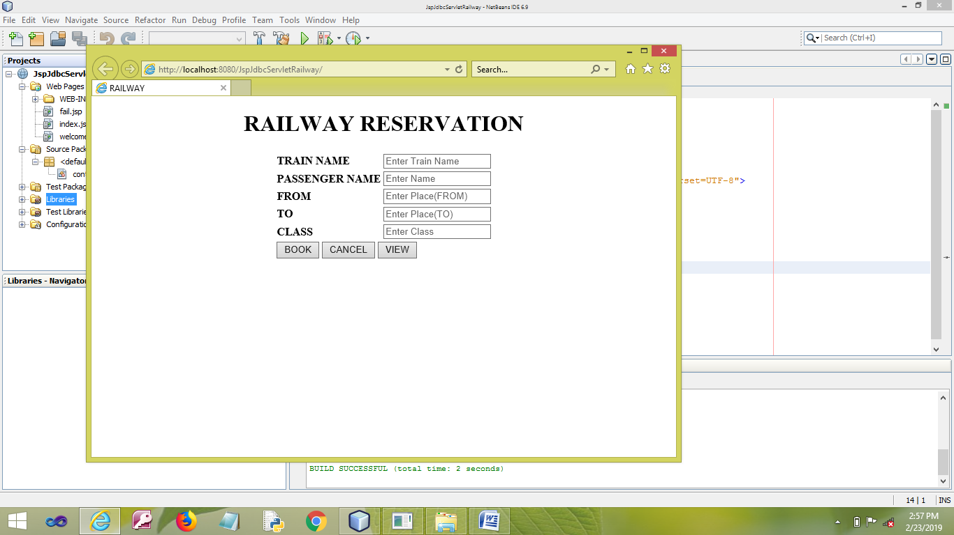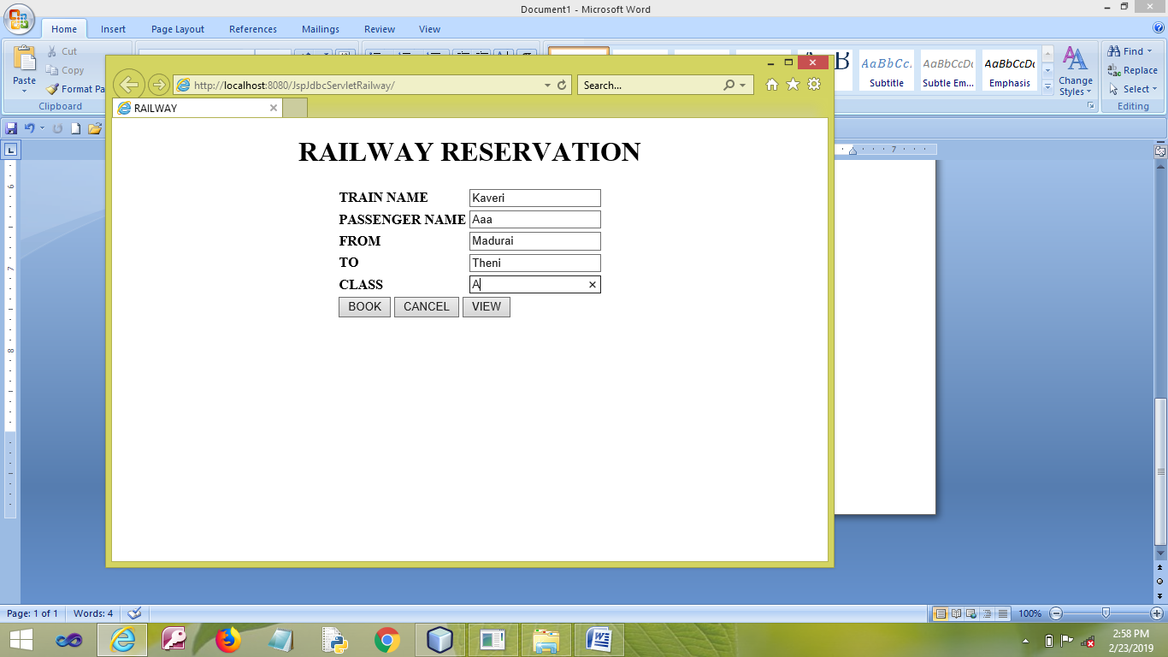

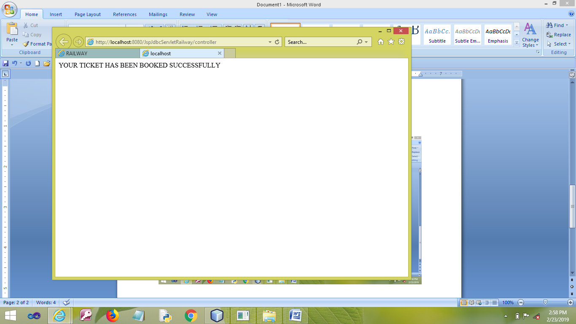

**RESULT**

Thus the program has been developed and executed successfully.

**AIM**

To Develop a Web Application for Student Details using JDBC and Struts.

**PROCEDURE**

**MYSQL**

* Open MYSQL.
* Create Database and Table.

|  |  |
| --- | --- |
| EX.NO: **08** | **STUDENT DETAILS USING STRUTS AND JDBC** |
| DATE: |

**NETBEANS**

* Open NetBeans IDE 6.9
* Open File →New Project.
* Choose Java Web →Web Application.
* Next.
* Give the Project a Name.
* Next →Next→Finish.
* Write Coding for **index.jsp** File.
* Right click on the Source Package.
* Select Others→Struts→Struts ActionForm Bean.
* Give the Form a Name.
* Finish.
* Right click on the Source Package.
* Select Others→Struts→Struts Action.
* Give the Action a Name.
* Specify the Action Path as in the **index.jsp** File.
* Next.
* Specify the Input Resource File Name by Browse Option.
* Finish.
* Right click on the Web Page of your Project.
* Select New →JSP.
* Give the File a Name **welcome**.
* Write coding for the success page on the **welcome.jsp** File..
* Right click on the Web Page of your Project.
* Finish.
* Select New →JSP.
* Give the File a Name **fail**.
* Write coding for the success page on the **fail.jsp** File.
* Finish.
* Make changes on the <action-mapping> in the **struts-config.xml** File.
* Right Click on the Libraries.
* Select Add Library … → MySQL JDBC Driver.
* Click Add Library.
* Save the Project.
* Run the Project.

**PROGRAM**

**MYSQL**

* create database **collegee**;
* use **student**;
* create table **student**(id varchar(20),name varchar(20),dept varchar(20));

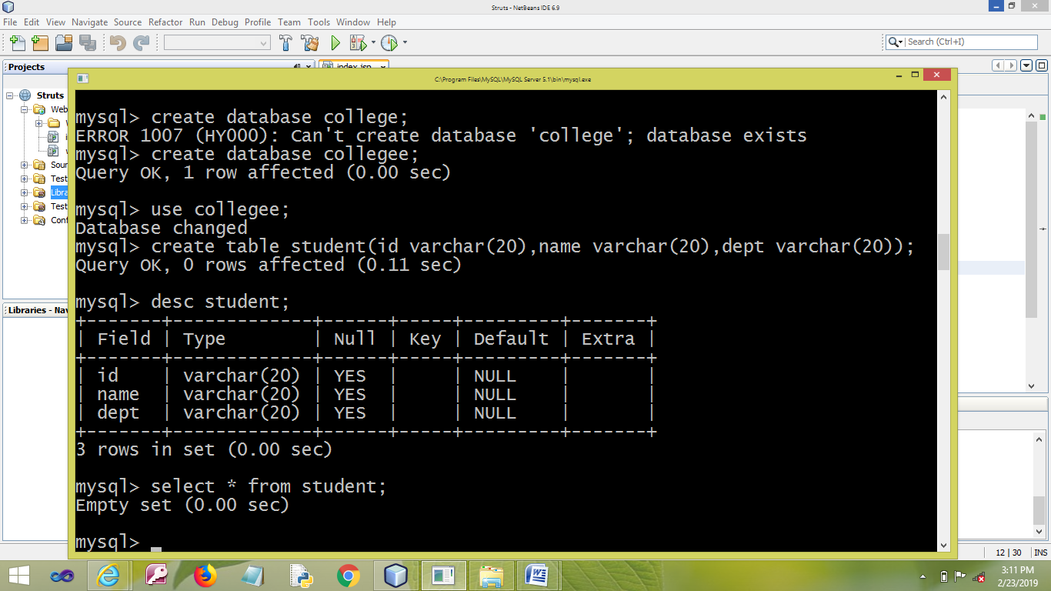

**NETBEANS**

**index.jsp**

<%@page contentType="text/html"%>

<%@page pageEncoding="UTF-8"%>

<%@ taglib uri="http://struts.apache.org/tags-html" prefix="html" %>

<html>

<body>

<center>

<html:form action="/useraction">

ENTER YOUR ID:

<html:text property="id" size="20" /><br><br>

ENTER YOUR NAME:

<html:text property="name" size="20" /><br><br>

ENTER YOUR DEPARTMENT:

<html:text property="dept" size="20" /><br><br>

<html:submit property="method" value="add"/>

<html:submit property="method" value="delete"/>

<html:submit property="method" value="search"/>

</html:form>

</center>

</body>

</html>

**stuformbean.java**

import javax.servlet.http.HttpServletRequest;

import org.apache.struts.action.*;

public class stuformbean extends org.apache.struts.action.ActionForm {

private String id;

public String getDept() {

return dept;

}

public void setDept(String dept) {

this.dept = dept;

}

public String getId() {

return id;

}

public void setId(String id) {

this.id = id;

}

public String getName() {

return name;

}

public void setName(String name) {

this.name = name;

}

private String name;

private String dept;

public stuformbean() {

super();

}

public ActionErrors validate(ActionMapping mapping, HttpServletRequest request) {

ActionErrors errors = new ActionErrors();

if (getName() == null || getName().length() < 1) {

errors.add("name", new ActionMessage("error.name.required"));

}

return errors;

}

}

**stuformaction.java**

import javax.servlet.http.HttpServletRequest;

import javax.servlet.http.HttpServletResponse;

import javax.servlet.http.HttpSession;

import org.apache.struts.action.*;

import org.apache.struts.actions.DispatchAction;

public class stuformaction extends DispatchAction {

public ActionForward add(ActionMapping mapping, ActionForm form,

HttpServletRequest request, HttpServletResponse response)

throws Exception {

HttpSession ses = request.getSession(true);

stuformbean registerForm = (stuformbean) form;

String id = registerForm.getId();

String name = registerForm.getName();

String dept = registerForm.getDept();

ses.setAttribute("id",id);

ses.setAttribute("name", name);

ses.setAttribute("dept", dept);

return mapping.findForward("add");

}

public ActionForward delete(ActionMapping mapping, ActionForm form,

HttpServletRequest request, HttpServletResponse response)

throws Exception

{

HttpSession ses = request.getSession(true);

stuformbean registerForm = (stuformbean) form;

String id= registerForm.getId();

ses.setAttribute("id", id);

return mapping.findForward("delete");

}

public ActionForward search(ActionMapping mapping, ActionForm form,

HttpServletRequest request, HttpServletResponse response)

throws Exception {

HttpSession ses = request.getSession(true);

stuformbean registerForm = (stuformbean) form;

String id= registerForm.getId();

ses.setAttribute("id", id);

return mapping.findForward("search");

}

}

**add.jsp**

<%@ page import ="java.sql.*" %>

<html>

<head>

<title>SUCCESS</title>

</head>

<body>

<% String a=session.getAttribute("id").toString(); %>

<% String b=session.getAttribute("name").toString(); %>

<% String c=session.getAttribute("dept").toString(); %>

<%

Class.forName("com.mysql.jdbc.Driver");

Connection con = DriverManager.getConnection("jdbc:mysql://localhost:3306/collegee","root","mysql");

Statement st= con.createStatement();

st.executeUpdate("insert into student values ('"+a+"','"+b+"','"+c+"')");

%>

<table><tr>SUCCESSFULLY INSERTED</tr><br><br>

</table>

</body>

</html>

**delete.jsp**

<%@ page import ="java.sql.*" %>

<%

String a=session.getAttribute("id").toString();

Class.forName("com.mysql.jdbc.Driver");

Connection con = DriverManager.getConnection("jdbc:mysql://localhost:3306/collegee","root","mysql");

Statement st= con.createStatement();

ResultSet rs=st.executeQuery("select * from student where id='" + a + "'");

if(!rs.next()) {

out.println("Id not exist");

} else {

st.executeUpdate("delete from student where id=('"+a+"')");

out.println("SUCCESSFULLY DELETED");

}

%>

**search.jsp**

<%@ page import ="java.sql.*" %>

<%

String a=session.getAttribute("id").toString();

Class.forName("com.mysql.jdbc.Driver");

Connection con = DriverManager.getConnection("jdbc:mysql://localhost:3306/collegee","root","mysql");

Statement st= con.createStatement();

ResultSet rs=st.executeQuery("select * from student where id='" + a + "'");

if(!rs.next()) {

out.println("Id not exist");

} else {

%>

<table>

<tr><th>NAME<th>DEPARTMENT</tr>

<tr><td><input type="text" disabled="disabled" value="<%=rs.getString(2)%>"></td>

<td><input type="text" disabled="disabled" value="<%=rs.getString(3)%>"></td></tr>

</table>

<%}%>

**struts-config.xml**

* + - Right click on the <action-mappings>
    - Select Struts→Add Forward.
    - Type the **jsp** File Name **add** and input resource file for the jsp File **add.jsp**.
    - Add.
    - Type the **jsp** File Name **delete** and input resource file for the jsp File **delete.jsp**.
    - Add.
    - Type the **jsp** File Name **search** and input resource file for the jsp File **search.jsp**.
    - Add.
    - Add **parameter=”method”** on the **<action-mappings>.**

**struts-config.xml**

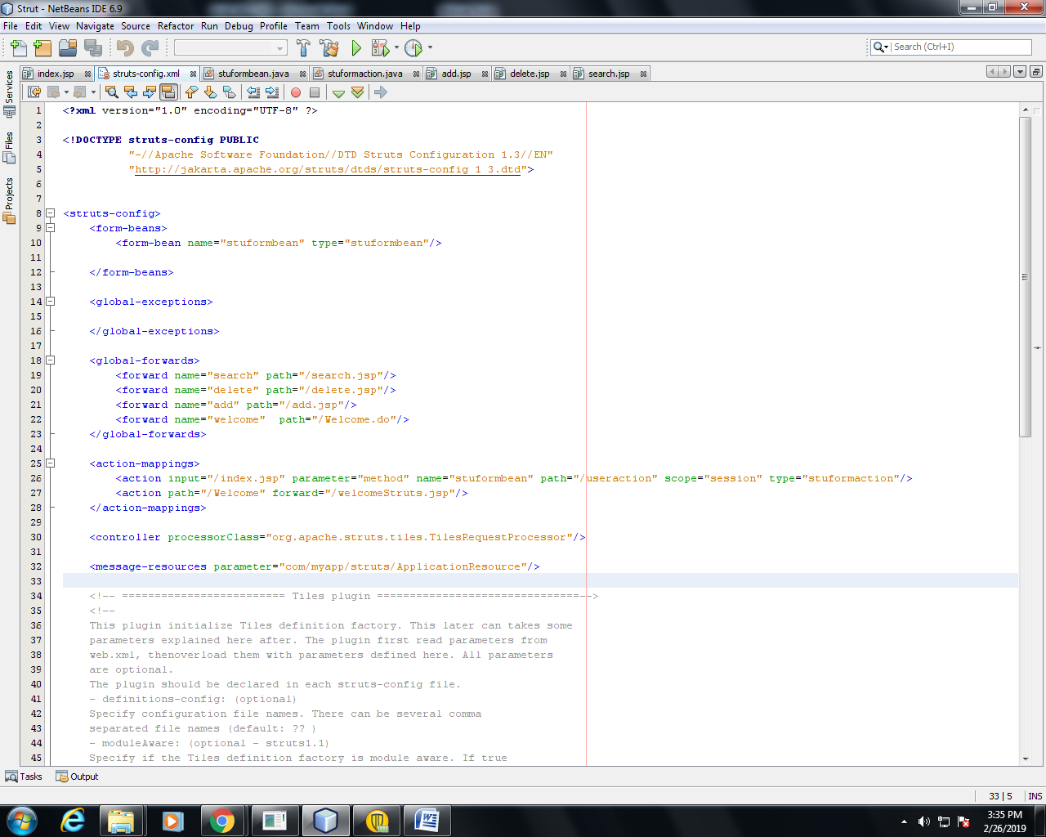

**OUTPUT**

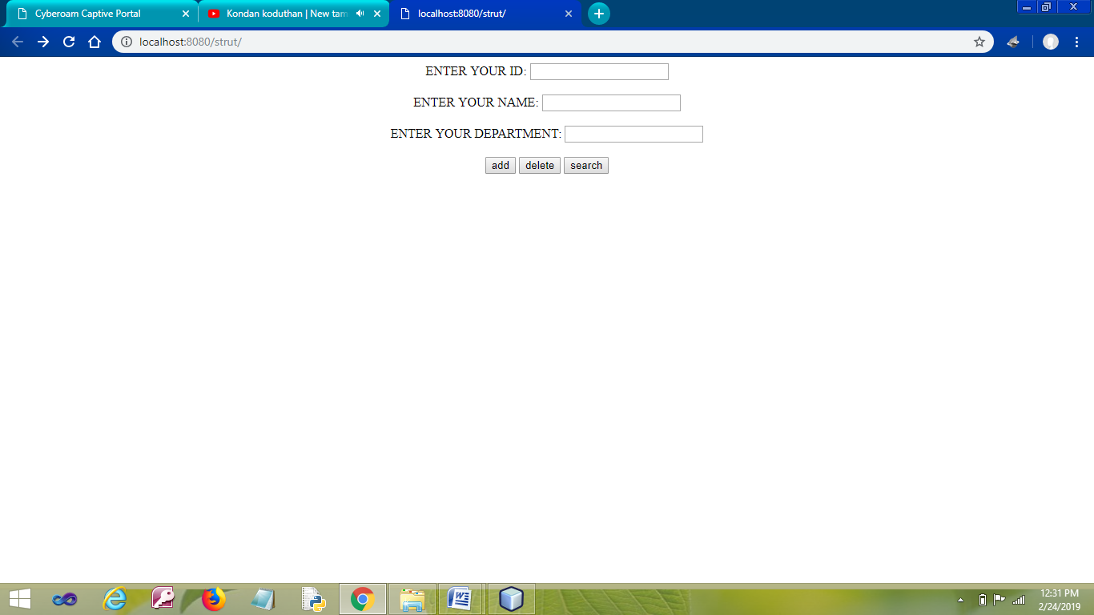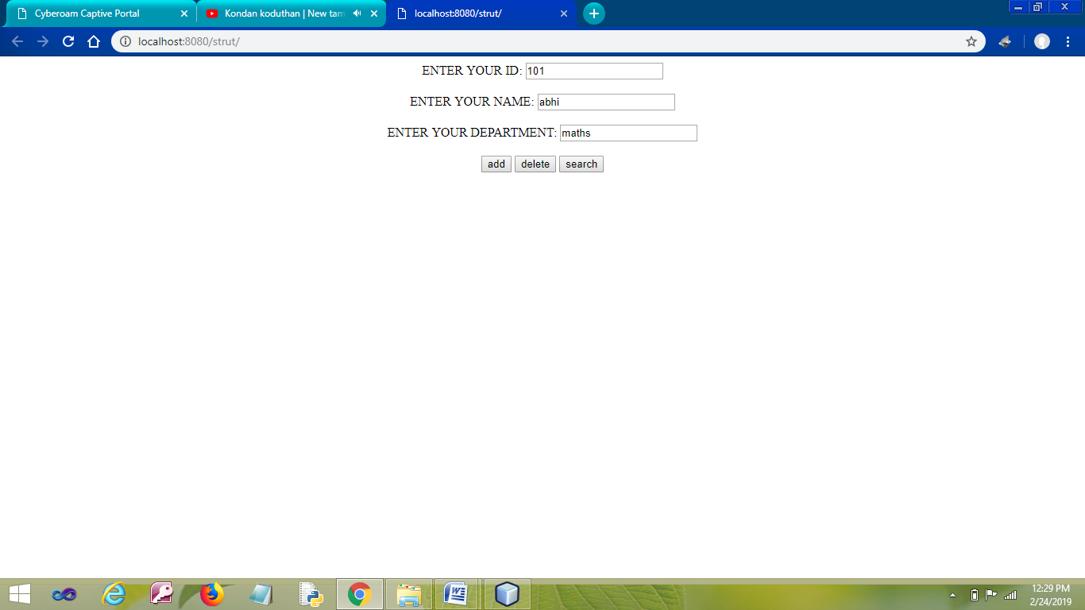

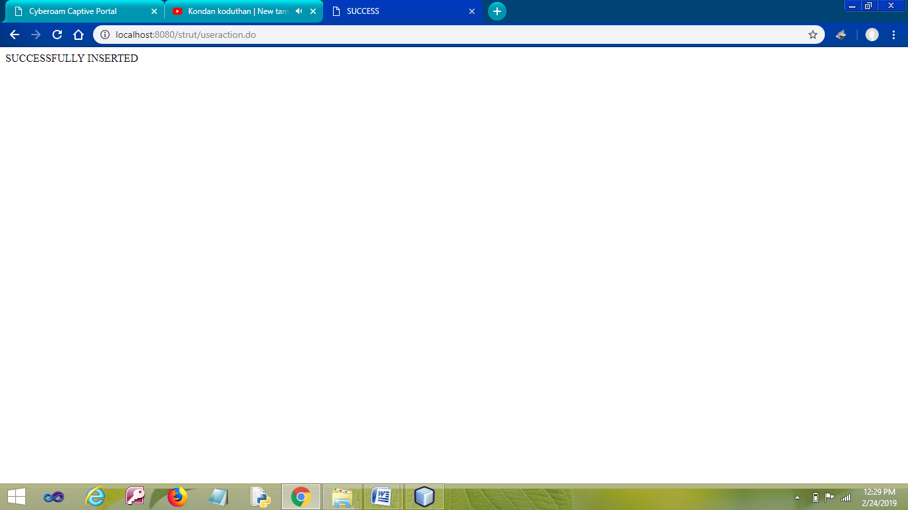

**RESULT**

Thus the program has been developed and executed successfully.

|  |  |
| --- | --- |
| EX.NO: **09** | **STUDENT DETAILS VALIDATION USING**  **STRUTS AND JDBC** |
| DATE: |

**AIM**

To Develop a Web Application for Student Details Validation using JDBC and Struts.

**PROCEDURE**

**MYSQL**

* Open MYSQL.
* Create Database and Table.

**NETBEANS**

* Open NetBeans IDE 6.9
* Open File →New Project.
* Choose Java Web →Web Application.
* Next.
* Give the Project a Name.
* Next →Next→Finish.
* Write Coding for **index.jsp** File.
* Right click on the Source Package.
* Select Others→Struts→Struts ActionForm Bean.
* Give the Form a Name.
* Finish.
* Right click on the Source Package.
* Select Others→Struts→Struts Action.
* Give the Action a Name.
* Specify the Action Path as in the **index.jsp** File.
* Next.
* Specify the Input Resource File Name by Browse Option.
* Finish.
* Right click on the Web Page of your Project.
* Select New →JSP.
* Give the File a Name **welcome**.
* Write coding for the success page on the **welcome.jsp** File..
* Right click on the Web Page of your Project.
* Finish.
* Select New →JSP.
* Give the File a Name **fail**.
* Write coding for the success page on the **fail.jsp** File.
* Finish.
* Make changes on the <action-mapping> in the **struts-config.xml** File.
* Make changes on the Source Packages→ com.myapp.struts→ **ApplicationResource.properties** File.
* Right Click on the Libraries.
* Select Add Library … → MySQL JDBC Driver.
* Click Add Library.
* Save the Project.
* Run the Project.

**PROGRAM**

**MYSQL**

* create database **collegee**;
* use **student**;
* create table **student**(id varchar(20),name varchar(20),dept varchar(20));



**NETBEANS**

**index.jsp**

<%@page contentType="text/html"%>

<%@page pageEncoding="UTF-8"%>

<%@ taglib uri="http://struts.apache.org/tags-html" prefix="html" %>

<html>

<body>

<center>

<html:form action="/useraction">

ENTER YOUR ID:

<html:text property="id" size="20" /><br><br>

<html:errors property="iderrors"/>

ENTER YOUR NAME:

<html:text property="name" size="20" /><br><br>

<html:errors property="nameerrors"/>

ENTER YOUR DEPARTMENT:

<html:text property="dept" size="20" /><br><br>

<html:errors property="depterrors"/>

<html:submit property="method" value="add"/>

<html:submit property="method" value="delete"/>

<html:submit property="method" value="search"/>

</html:form>

</center>

</body>

</html>

**stuformbean.java**

import javax.servlet.http.HttpServletRequest;

import org.apache.struts.action.*;

public class stuformbean extends org.apache.struts.action.ActionForm {

private String id;

public String getDept() {

return dept;

}

public void setDept(String dept) {

this.dept = dept;

}

public String getId() {

return id;

}

public void setId(String id) {

this.id = id;

}

public String getName() {

return name;

}

public void setName(String name) {

this.name = name;

}

private String name;

private String dept;

public stuformbean() {

super();

}

public ActionErrors validate(ActionMapping mapping, HttpServletRequest request) {

ActionErrors errors = new ActionErrors();

if (getName() == null || getName().length() < 1) {

errors.add("iderrors", new ActionMessage("error.id.required"));

}

if(getName() == null || getName().length() < 1) {

errors.add("nameerrors", new ActionMessage("error.name.required"));

}

if(getName() == null || getName().length() < 1) {

errors.add("depterrors", new ActionMessage("error.dept.required"));

}

return errors;

}

}

**stuformaction.java**

import javax.servlet.http.HttpServletRequest;

import javax.servlet.http.HttpServletResponse;

import javax.servlet.http.HttpSession;

import org.apache.struts.action.*;

import org.apache.struts.actions.DispatchAction;

public class stuformaction extends DispatchAction {

public ActionForward add(ActionMapping mapping, ActionForm form,

HttpServletRequest request, HttpServletResponse response)

throws Exception {

HttpSession ses = request.getSession(true);

stuformbean registerForm = (stuformbean) form;

String id = registerForm.getId();

String name = registerForm.getName();

String dept = registerForm.getDept();

ses.setAttribute("id",id);

ses.setAttribute("name", name);

ses.setAttribute("dept", dept);

return mapping.findForward("add");

}

public ActionForward delete(ActionMapping mapping, ActionForm form,

HttpServletRequest request, HttpServletResponse response)

throws Exception {

HttpSession ses = request.getSession(true);

stuformbean registerForm = (stuformbean) form;

String id= registerForm.getId();

ses.setAttribute("id", id);

return mapping.findForward("delete");

}

public ActionForward search(ActionMapping mapping, ActionForm form,

HttpServletRequest request, HttpServletResponse response)

throws Exception {

HttpSession ses = request.getSession(true);

stuformbean registerForm = (stuformbean) form;

String id= registerForm.getId();

ses.setAttribute("id", id);

return mapping.findForward("search");

}

}

**add.jsp**

<%@ page import ="java.sql.*" %>

<html>

<head>

<title>SUCCESS</title>

</head>

<body>

<% String a=session.getAttribute("id").toString(); %>

<% String b=session.getAttribute("name").toString(); %>

<% String c=session.getAttribute("dept").toString(); %>

<%

Class.forName("com.mysql.jdbc.Driver");

Connection con = DriverManager.getConnection("jdbc:mysql://localhost:3306/collegee","root","mysql");

Statement st= con.createStatement();

st.executeUpdate("insert into student values ('"+a+"','"+b+"','"+c+"')");

%>

<table><tr>SUCCESSFULLY INSERTED</tr><br><br>

</table>

</body>

</html>

**delete.jsp**

<%@ page import ="java.sql.*" %>

<%

String a=session.getAttribute("id").toString();

Class.forName("com.mysql.jdbc.Driver");

Connection con = DriverManager.getConnection("jdbc:mysql://localhost:3306/collegee","root","mysql");

Statement st= con.createStatement();

ResultSet rs=st.executeQuery("select * from student where id='" + a + "'");

if(!rs.next()) {

out.println("Id not exist");

} else {

st.executeUpdate("delete from student where id=('"+a+"')");

out.println("SUCCESSFULLY DELETED");

}

%>

**search.jsp**

<%@ page import ="java.sql.*" %>

<%

String a=session.getAttribute("id").toString();

Class.forName("com.mysql.jdbc.Driver");

Connection con = DriverManager.getConnection("jdbc:mysql://localhost:3306/collegee","root","mysql");

Statement st= con.createStatement();

ResultSet rs=st.executeQuery("select * from student where id='" + a + "'");

if(!rs.next()) {

out.println("Id not exist");

} else {

%>

<table>

<tr><th>NAME<th>DEPARTMENT</tr>

<tr><td><input type="text" disabled="disabled" value="<%=rs.getString(2)%>"></td>

<td><input type="text" disabled="disabled" value="<%=rs.getString(3)%>"></td></tr>

</table>

<%}%>

**struts-config.xml**

* + - Right click on the <action-mappings>
    - Select Struts→Add Forward.
    - Type the **jsp** File Name **add** and input resource file for the jsp File **add.jsp**.
    - Add.
    - Type the **jsp** File Name **delete** and input resource file for the jsp File **delete.jsp**.
    - Add.
    - Type the **jsp** File Name **search** and input resource file for the jsp File **search.jsp**.
    - Add.
    - Add **parameter=”method”** on the **<action-mappings>.**

**struts-config.xml**



**ApplicationResource.properties**

* + - Include these statements at the end of the file.

error.id.required=PLEASE ENTER ID

error.name.required=PLEASE ENTER NAME

error.dept.required=PLEASE ENTER DEPARTMENT

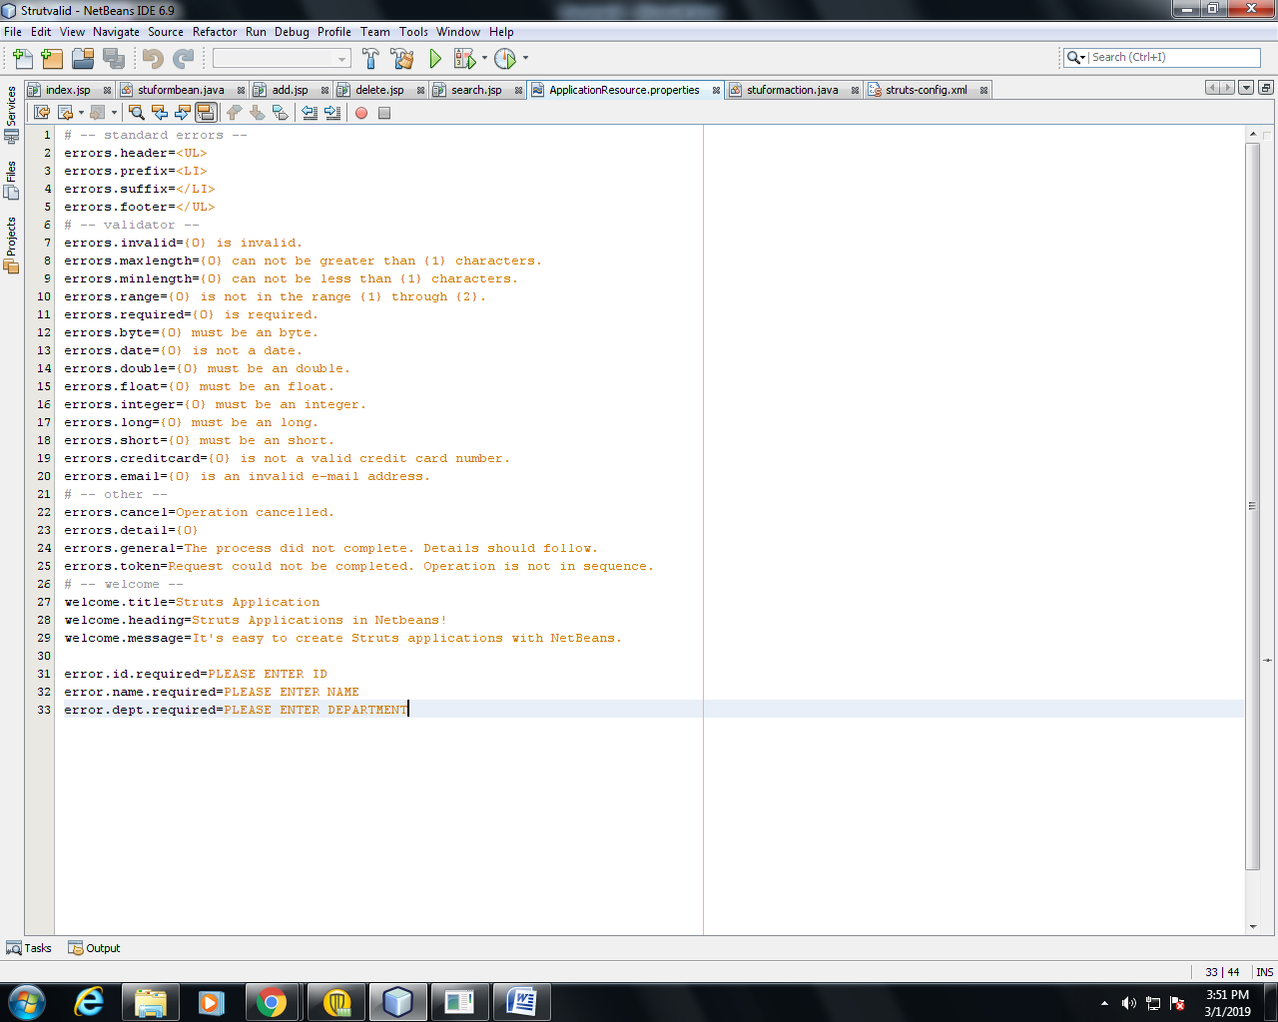

**OUTPUT**

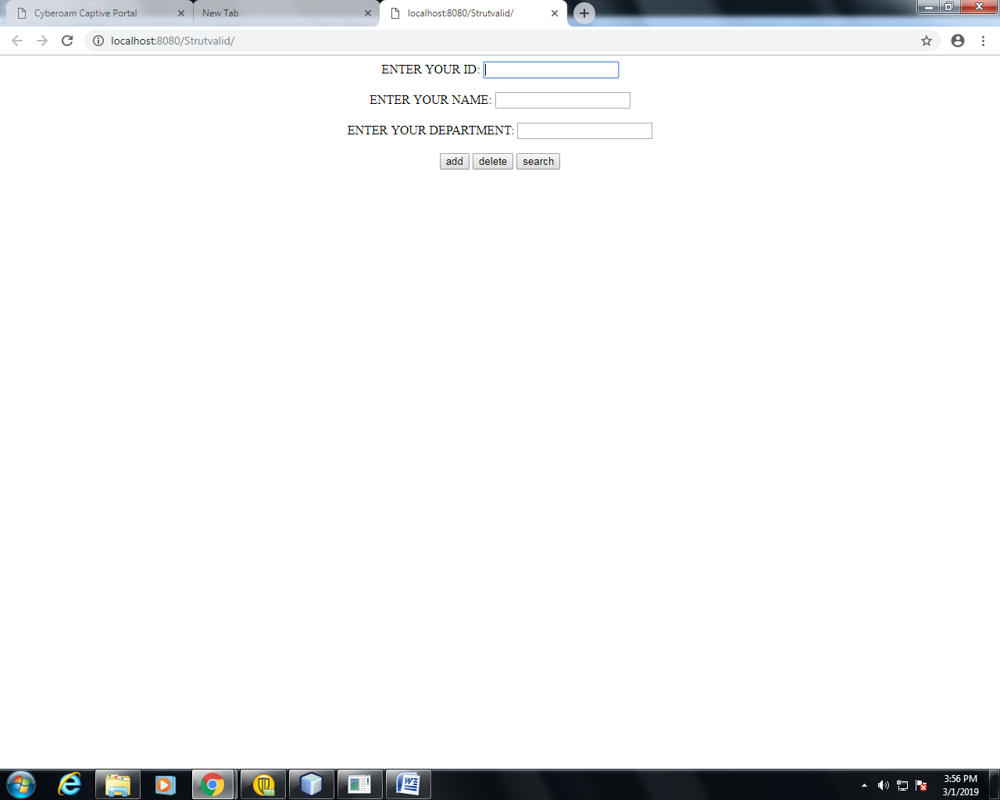

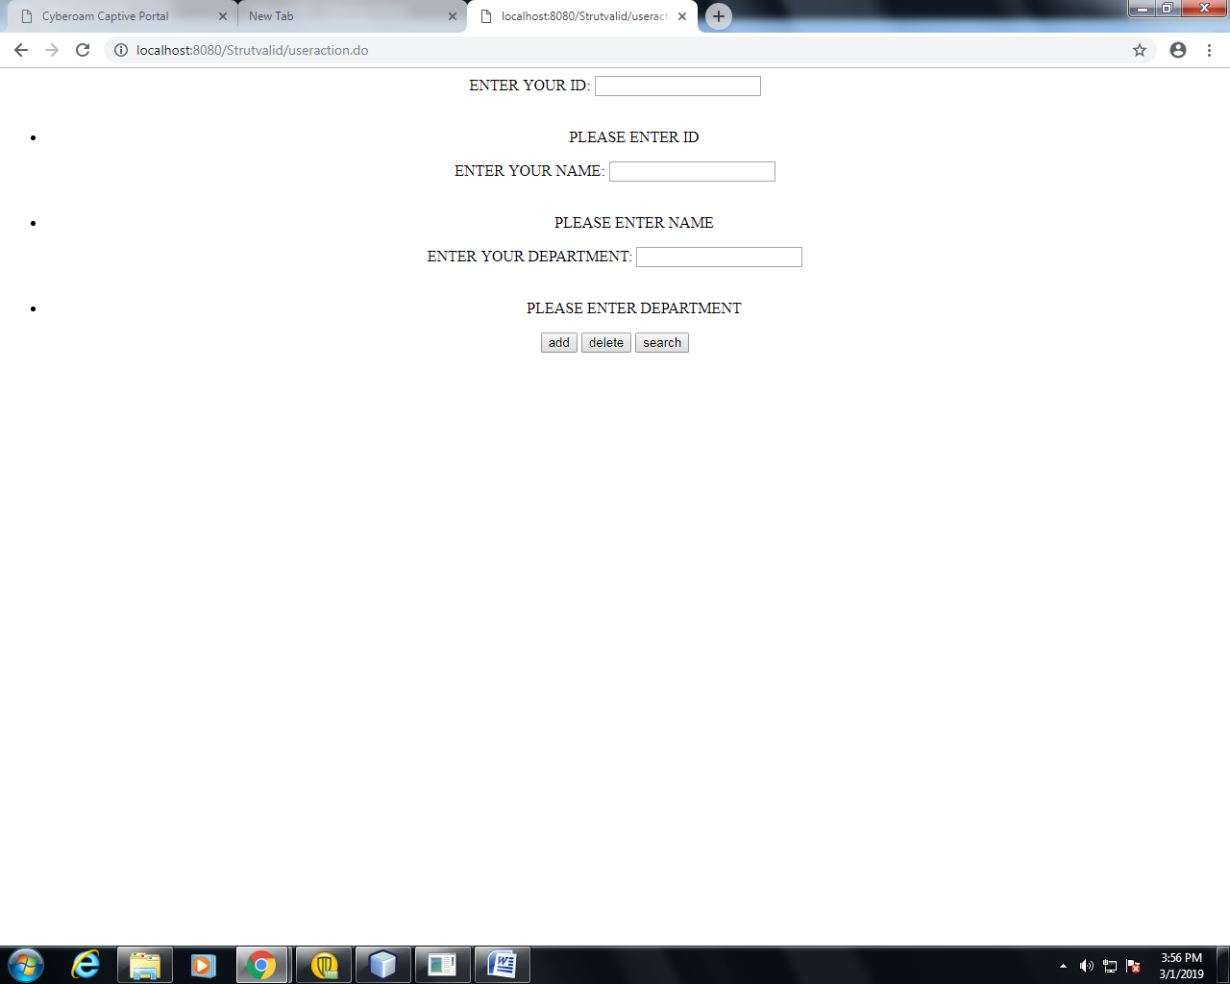 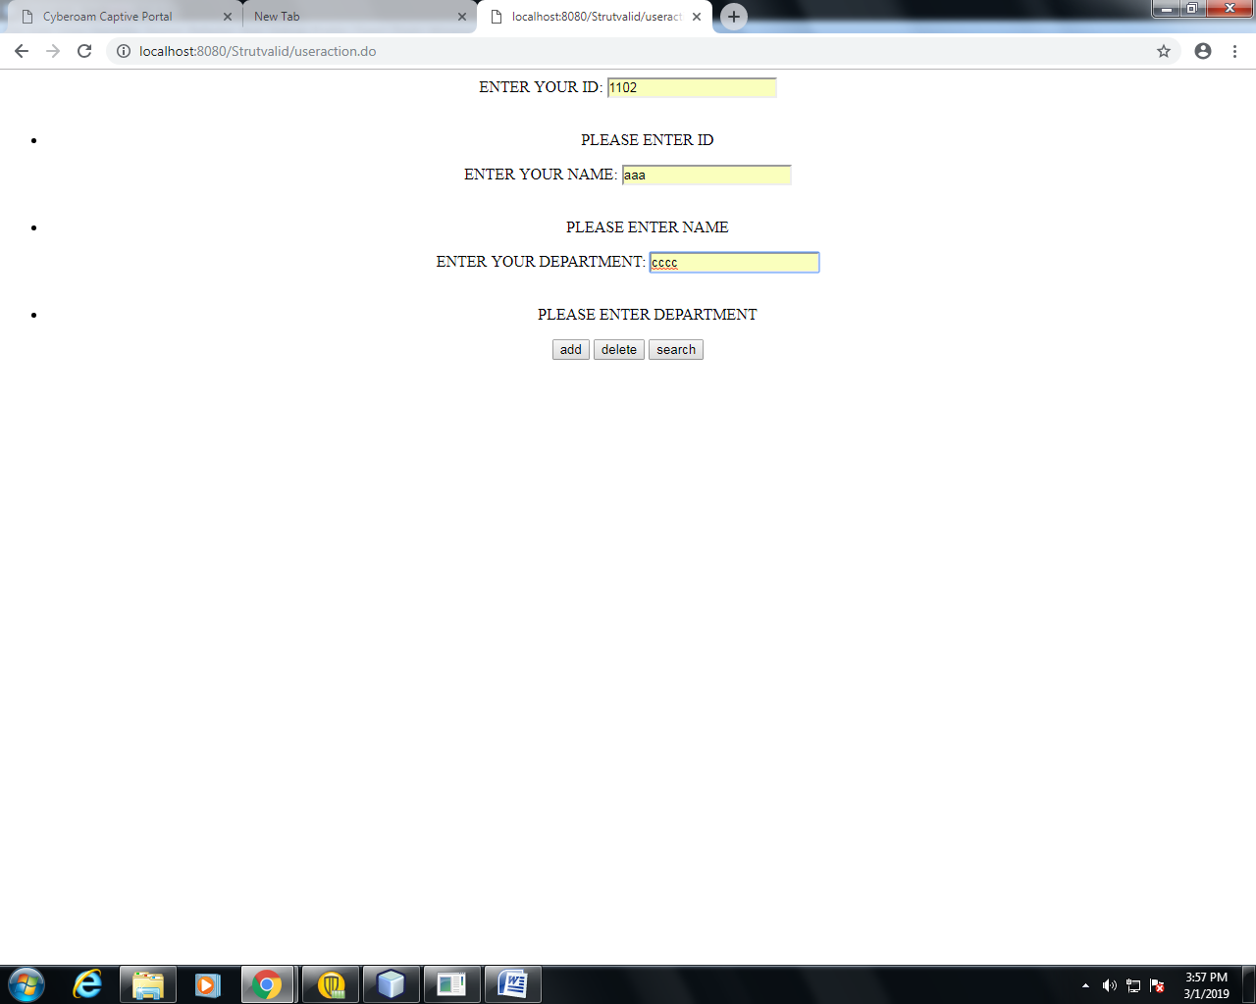

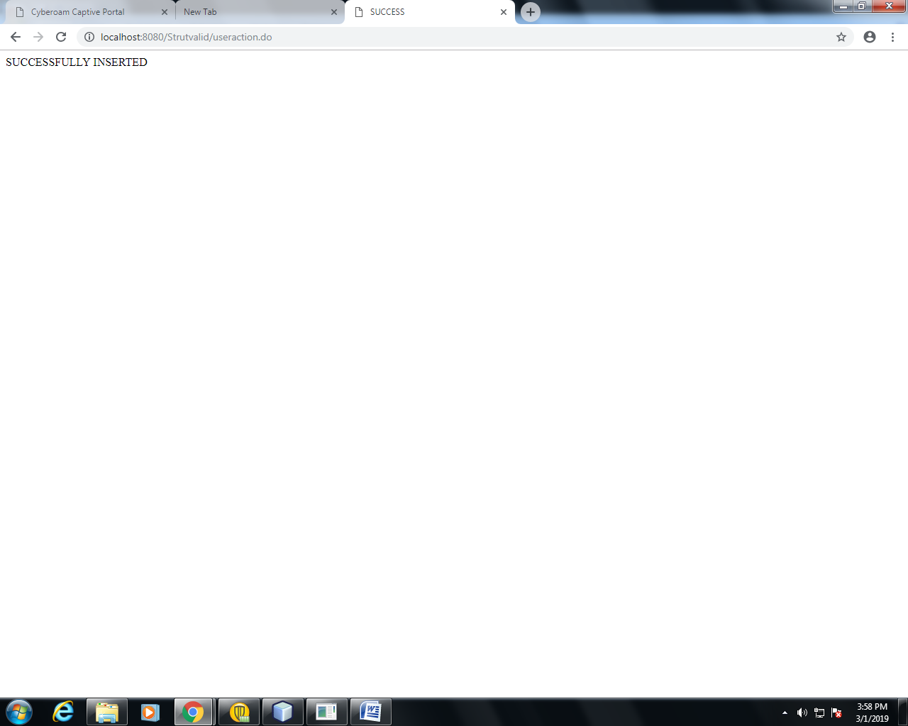

**RESULT**

Thus the program has been developed and executed successfully.

|  |  |
| --- | --- |
| EX.NO: **10** | **STUDENT DETAILS USING SPRING** |
| DATE: |

**AIM**

To Develop a Web Application for Student Details using Spring MVC.

**PROCEDURE**

**NETBEANS**

* Open NetBeans IDE 6.9
* Open File →New Project.
* Choose Java Web →Web Application.
* Next.
* Give the Project a Name.
* Next →Next→Finish.
* Right click on the **jsp** File.
* Select new→ **JSP** .
* Give the jsp File a name **(studentinput.jsp)**.
* Finish.
* Right click on the **jsp** File.
* Select new→ **JSP.**
* Give the jsp File a name **(studentview.jsp)**.
* Finish.
* Make changes on the **redirect.jsp** File.
* Make changes to the **dispatcher-servlet.xml**.
* Right click on the **Source Package**.
* Select new→ **Java class**.
* Give a name for the java class **( Student.java )** and the package **(studentregister)**.
* Finish.
* Right click on the studentregister package.
* Select new→ **Java class**.
* Give a name for the java class **( StudentController.java )**.
* Finish.
* Save the Project.
* Run the Project.

**PROGRAM**

**studentinput.jsp**

<%@page contentType="text/html" pageEncoding="UTF-8"%>

<%@taglib uri="http://www.springframework.org/tags/form" prefix="form" %>

<!DOCTYPE HTML PUBLIC "-//W3C//DTD HTML 4.01 Transitional//EN"

"http://www.w3.org/TR/html4/loose.dtd">

<html>

<head>

<meta http-equiv="Content-Type" content="text/html; charset=UTF-8">

<title>STUDENT INPUT PAGE</title>

</head>

<body>

<center>

<form:form action="output" method="post">

<table cellpading="10" cellspacing="5">

<tr>

<td> Enter the Name</td>

<td><form:input path="name"/></td>

</tr>

<tr>

<td> Enter the Degree</td>

<td><form:input path="degree"/></td>

</tr>

<tr>

<td> Enter the Register No</td>

<td><form:input path="regno"/></td>

</tr>

<tr>

<td> Enter the CGPA</td>

<td><form:input path="cgpa"/></td>

</tr>

<tr>

<td></td>

<td><input type="submit" name="s1" value="SUBMIT"/></td>

</tr>

</table>

</form:form>

</center>

</body>

</html>

**studentview.jsp**

<%@page contentType="text/html" pageEncoding="UTF-8"%>

<%@taglib uri="http://www.springframework.org/tags/form" prefix="form" %>

<!DOCTYPE HTML PUBLIC "-//W3C//DTD HTML 4.01 Transitional//EN"

"http://www.w3.org/TR/html4/loose.dtd">

<html>

<head>

<meta http-equiv="Content-Type" content="text/html; charset=UTF-8">

<title>STUDENT VIEW PAGE</title>

</head>

<body>

<center>

<table border="3" cellpading="10" cellspacing="5">

<tr>

<td> Name</td>

<td>${stud.name}</td>

</tr>

<tr>

<td>Degree</td>

<td>${stud.degree}</td>

</tr>

<tr>

<td>Register No</td>

<td>${stud.regno}</td>

</tr>

<tr>

<td>CGPA</td>

<td>${stud.cgpa}</td>

</tr>

</table>

</center>

</body>

</html>

**redirect.jsp**

* + - Include this at the end of the File by removing the last Line.

<% response.sendRedirect("studentinput"); %>

**dispatcher-servlet.xml**

<?xml version="1.0" encoding="UTF-8"?>

<beans xmlns="http://www.springframework.org/schema/beans"

xmlns:context="http://www.springframework.org/schema/context"

xmlns:xsi="http://www.w3.org/2001/XMLSchema-instance"

xsi:schemaLocation="

http://www.springframework.org/schema/beans

http://www.springframework.org/schema/beans/spring-beans-3.0.xsd

http://www.springframework.org/schema/context

http://www.springframework.org/schema/context/spring-context-3.0.xsd">

<context:component-scan base-package="studentregister" />

<bean

class="org.springframework.web.servlet.view.InternalResourceViewResolver" >

<property name="prefix" value="/WEB-INF/jsp/" />

<property name="suffix" value=".jsp" />

</bean>

</beans>

**Student.java**

package studentregister;

public class Student {

private String name,degree;

private int regno;

private float cgpa;

public float getCgpa() {

return cgpa;

}

public void setCgpa(float cgpa) {

this.cgpa = cgpa;

}

public String getDegree() {

return degree;

}

public void setDegree(String degree) {

this.degree = degree;

}

public String getName() {

return name;

}

public void setName(String name) {

this.name = name;

}

public int getRegno() {

return regno;

}

public void setRegno(int regno) {

this.regno = regno;

}

public Student(String name, String degree, int regno, float cgpa) {

this.name = name;

this.degree = degree;

this.regno = regno;

this.cgpa = cgpa;

}

public Student() {

}

}

**StudentController.java**

package studentregister;

import org.springframework.stereotype.Controller;

import org.springframework.ui.ModelMap;

import org.springframework.web.bind.annotation.RequestMapping;

import org.springframework.web.bind.annotation.RequestMethod;

import org.springframework.web.servlet.ModelAndView;

@Controller

public class StudentController {

@RequestMapping(value="/studentinput",method=RequestMethod.GET)

public ModelAndView setStudentInfo(){

return new ModelAndView("studentinput","command",new Student());

}

@RequestMapping(value="/output",method=RequestMethod.POST)

public String showStudentInfo(Student s1,ModelMap model){

model.addAttribute("stud",s1);

return "studentview";

}

}

**OUTPUT**

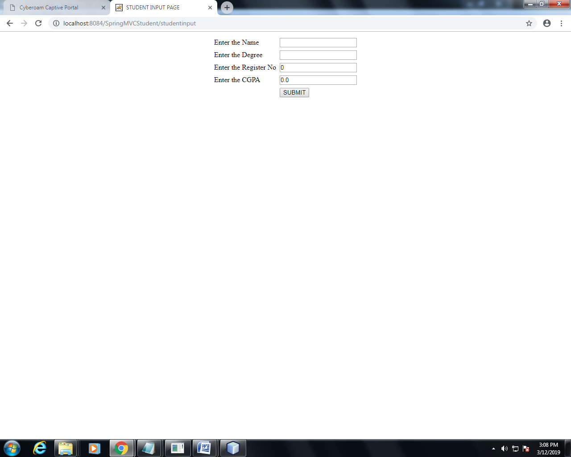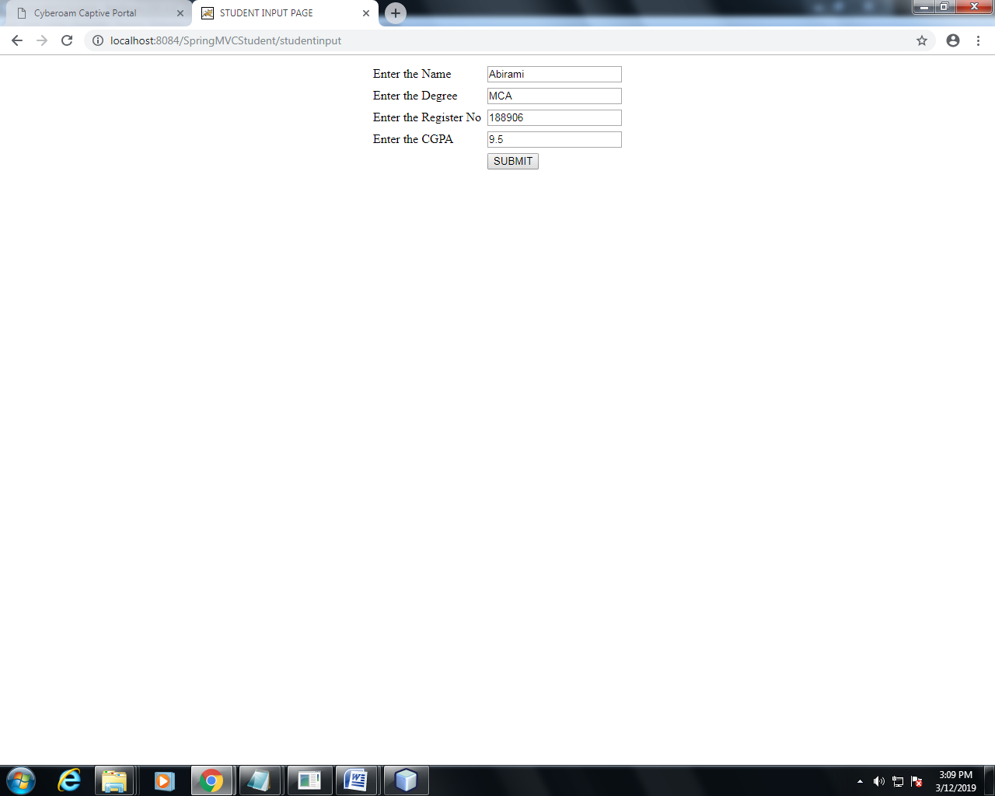

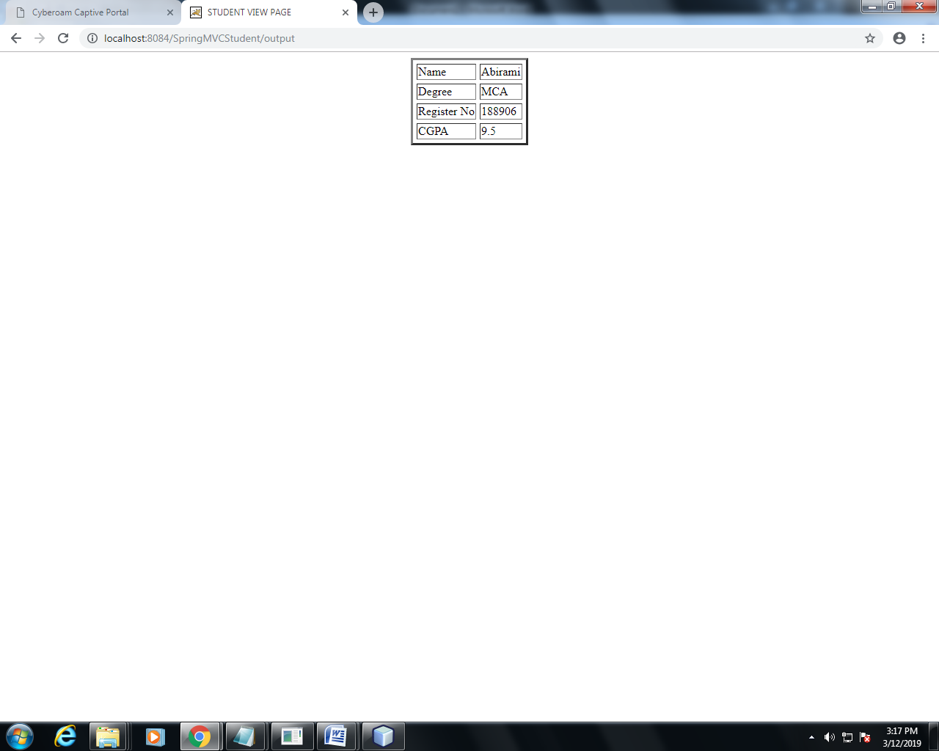

**RESULT**

Thus the program has been developed and executed successfully.

|  |  |
| --- | --- |
| EX.NO: **11** | **BOOK STORE USING SPRING** |
| DATE: |

**AIM**

To Develop a Web Application for Book Store using Spring MVC.

**PROCEDURE**

**NETBEANS**

* Open NetBeans IDE 6.9
* Open File →New Project.
* Choose Java Web →Web Application.
* Next.
* Give the Project a Name.
* Next →Next→Finish.
* Right click on the **jsp** File.
* Select new→ **JSP** .
* Give the jsp File a name **(bookinput.jsp)**.
* Finish.
* Right click on the **jsp** File.
* Select new→ **JSP.**
* Give the jsp File a name **(bookview.jsp)**.
* Finish.
* Make changes on the **redirect.jsp** File.
* Make changes to the **dispatcher-servlet.xml**.
* Right click on the **Source Package**.
* Select new→ **Java class**.
* Give a name for the java class **( Book.java )** and the package **(store)**.
* Finish.
* Right click on the studentregister package.
* Select new→ **Java class**.
* Give a name for the java class **( BookController.java )**.
* Finish.
* Save the Project.
* Run the Project.

**PROGRAM**

**bookinput.jsp**

<%@page contentType="text/html" pageEncoding="UTF-8"%>

<%@taglib uri="http://www.springframework.org/tags/form" prefix="form" %>

<!DOCTYPE HTML PUBLIC "-//W3C//DTD HTML 4.01 Transitional//EN"

"http://www.w3.org/TR/html4/loose.dtd">

<html>

<head>

<meta http-equiv="Content-Type" content="text/html; charset=UTF-8">

<title>BOOK STORE PAGE</title>

</head>

<body>

<center>

<form:form action="output" method="post">

<table border="3" cellpading="10" cellspacing="5">

<tr>

<td> Enter the Book Name</td>

<td><form:input path="name"/></td>

</tr>

<tr>

<td> Enter the Author of the Book</td>

<td><form:input path="author"/></td>

</tr>

<tr>

<td> Enter the Quantity</td>

<td><form:input path="quantity"/></td>

</tr>

<tr>

<td> Enter the Price of the Book</td>

<td><form:input path="price"/></td>

</tr>

<tr>

<td></td>

<td><input type="submit" name="s1" value="REGISTER"/></td>

</tr>

</table>

</form:form>

</center>

</body>

</html>

**bookview.jsp**

<%@page contentType="text/html" pageEncoding="UTF-8"%>

<%@taglib uri="http://www.springframework.org/tags/form" prefix="form" %>

<!DOCTYPE HTML PUBLIC "-//W3C//DTD HTML 4.01 Transitional//EN"

"http://www.w3.org/TR/html4/loose.dtd">

<html>

<head>

<meta http-equiv="Content-Type" content="text/html; charset=UTF-8">

<title>BOOK VIEW PAGE</title>

</head>

<body>

<center>

<table border="3" cellpading="10" cellspacing="5">

<tr>

<td>Book Name</td>

<td>${bk.name}</td>

</tr>

<tr>

<td>Author</td>

<td>${bk.author}</td>

</tr>

<tr>

<td>Quantity</td>

<td>${bk.quantity}</td>

</tr>

<tr>

<td>Price</td>

<td>${bk.price}</td>

</tr>

</table>

</center>

</body>

</html>

**redirect.jsp**

* + - Include this at the end of the File by removing the last Line.

<% response.sendRedirect("studentinput"); %>

**dispatcher-servlet.xml**

<?xml version="1.0" encoding="UTF-8"?>

<beans xmlns="http://www.springframework.org/schema/beans"

xmlns:context="http://www.springframework.org/schema/context"

xmlns:xsi="http://www.w3.org/2001/XMLSchema-instance"

xsi:schemaLocation="

http://www.springframework.org/schema/beans

http://www.springframework.org/schema/beans/spring-beans-3.0.xsd

http://www.springframework.org/schema/context

http://www.springframework.org/schema/context/spring-context-3.0.xsd">

<context:component-scan base-package="studentregister" />

<bean

class="org.springframework.web.servlet.view.InternalResourceViewResolver" >

<property name="prefix" value="/WEB-INF/jsp/" />

<property name="suffix" value=".jsp" />

</bean>

</beans>

**Book.java**

package store;

public class Book {

private String name,author;

private int quantity;

private float price;

public String getAuthor() {

return author;

}

public void setAuthor(String author) {

this.author = author;

}

public String getName() {

return name;

}

public void setName(String name) {

this.name = name;

}

public float getPrice() {

return price;

}

public void setPrice(float price) {

this.price = price;

}

public int getQuantity() {

return quantity;

}

public void setQuantity(int quantity) {

this.quantity = quantity;

}

public Book(String name, String author, int quantity, float price) {

this.name = name;

this.author = author;

this.quantity = quantity;

this.price = price;

}

public Book() {

}

}

**BookController.java**

package store;

import org.springframework.stereotype.Controller;

import org.springframework.ui.ModelMap;

import org.springframework.web.bind.annotation.RequestMapping;

import org.springframework.web.bind.annotation.RequestMethod;

import org.springframework.web.servlet.ModelAndView;

@Controller

public class BookController {

@RequestMapping(value="/bookinput",method=RequestMethod.GET)

public ModelAndView setBookInfo(){

return new ModelAndView("bookinput","command",new Book());

}

@RequestMapping(value="/output",method=RequestMethod.POST)

public String showBookInfo(Book b1,ModelMap model){

model.addAttribute("bk",b1);

return "bookview";

}

}

**OUTPUT**

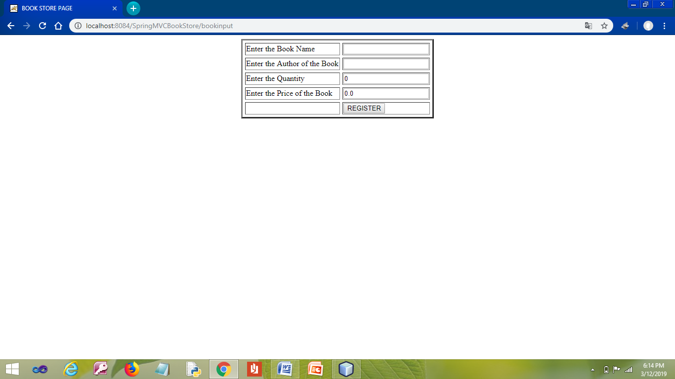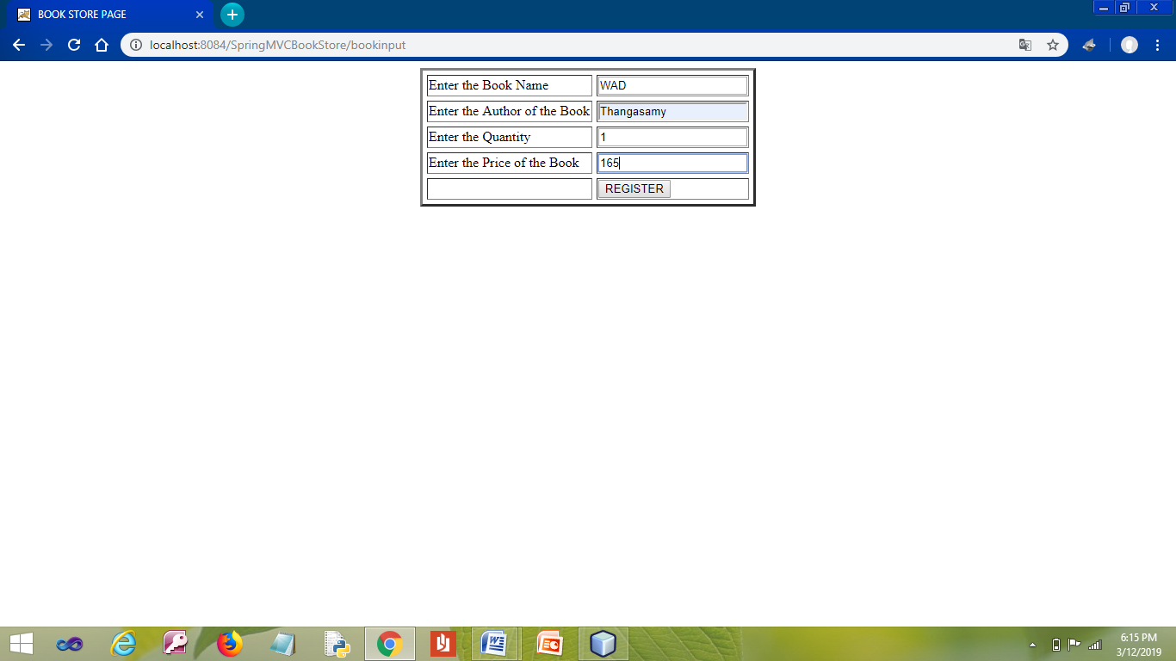

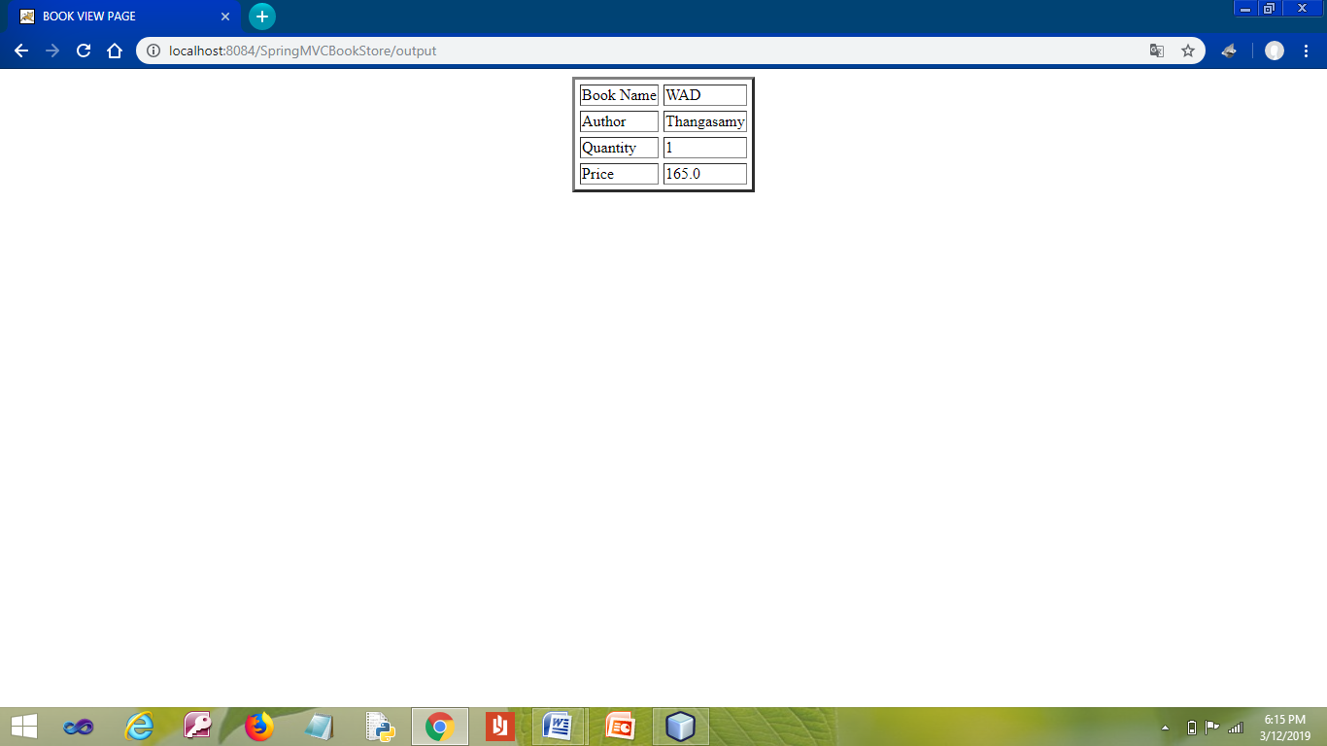

**RESULT**

Thus the program has been developed and executed successfully.

|  |  |
| --- | --- |
| EX.NO: **12** | **VEHICLE DETAILS VALIDATION**  **USING ANNOTATIONS SPRING** |
| DATE: |

**AIM**

To Develop a Web Application for Vehicle Details Validations using Annotations Using Spring MVC.

**PROCEDURE**

**NETBEANS**

* Open NetBeans IDE 6.9
* Open File →New Project.
* Choose Java Web →Web Application.
* Next.
* Give the Project a Name.
* Next →Next.
* Click the Check Box **Spring Web MVC**.
* Make changes on the **Configuration** settings.
* Change Dispatcher Mapping as **/**.
* Finish.
* Write codings for the **index.jsp** File.
* Right Click on the **jsp** File.
* Select new→ JSP.
* Give the jsp file a name **(success.jsp)**.
* Finish.
* Include two jar Files by right clicking on the Add Jar/Folder.
* Select the jar Files from C:→Program Files→NetBeans 6.9→ide→modules→ext.
  + mysql-connector-java-5.1.6-bin.jar
  + validation-api-2.0.0.Final.jar **( Download from Net )**
* Add.
* Make changes to the **dispatcher-servlet.xml**.
* Right click on the **Source Package**.
* Select new→ **Java class**.
* Give a name for the java class **( Driver.java )** and the package **(springcontroller)**.
* Finish.
* Right click on the springcontroller package.
* Select new→ **Java class**.
* Give a name for the java class **( SaveUser.java )**.
* Finish.
* Save the Project.
* Run the Project.

**PROGRAM**

**index.jsp**

<%@page contentType="text/html" pageEncoding="UTF-8"%>

<%@taglib uri="http://www.springframework.org/tags/form" prefix="f" %>

<!DOCTYPE HTML PUBLIC "-//W3C//DTD HTML 4.01 Transitional//EN"

"http://www.w3.org/TR/html4/loose.dtd">

<html>

<head>

<meta http-equiv="Content-Type" content="text/html; charset=UTF-8">

<title>Welcome to Spring Web MVC project</title>

</head>

<style>

input{

padding: 10px;

border-radius: 5px;

width: 100%;

}

button {

padding: 10px;

border-radius: 5px;

background: #4285F5;

border: 1px solid #4285F5;

color: #fff;

}

</style>

<body style="width: 100%">

<div style="margin: auto; width: 34%; border: 1px solid #cacaca; border-radius: 5px;">

<h2 style="text-align: center;">Driver Form</h2>

<f:form action="http://localhost:8080/SpringValidations/saveuser" method="post" style="padding: 50px;">

<f:input type="text" path="name" placeholder="Enter Driver Name"/>

<font color='red'><form:errors path='name' /></font>

<br>

<br>

<f:input type="number" path="age" placeholder="Enter Age"/>

<font color='red'><form:errors path='age' /></font>

<br>

<br>

<f:input type="text" path="vehicleno" placeholder="Enter Vehicle Number"/>

<font color='red'><form:errors path='vehicleno' /></font>

<br>

<br>

<%String error = request.getParameter("error") != null ? request.getParameter("error") : "";%>

<p style="color: red;"><%=error%></p>

<button type="submit">Add Driver</button>

</f:form>

</div>

</body>

</html>

**success.jsp**

<%@page contentType="text/html" pageEncoding="UTF-8"%>

<!DOCTYPE html>

<html>

<head>

<meta http-equiv="Content-Type" content="text/html; charset=UTF-8">

<title>JSP Page</title>

</head>

<body>

<h1>Driver Added Successfull</h1>

<br>

<br>

<h2>Name: <span>${driver.name}</span></h2>

<h2>Age: <span>${driver.age}</span></h2>

<h2>Vehicle No: <span>${driver.vehicleno}</span></h2>

</body>

</html>

**dispatcher-servlet.xml**

<?xml version="1.0" encoding="UTF-8"?>

<beans xmlns="http://www.springframework.org/schema/beans"

xmlns:xsi="http://www.w3.org/2001/XMLSchema-instance" xmlns:context="http://www.springframework.org/schema/context"

xmlns:mvc="http://www.springframework.org/schema/mvc"

xsi:schemaLocation="

http://www.springframework.org/schema/beans http://www.springframework.org/schema/beans/spring-beans.xsd

http://www.springframework.org/schema/context http://www.springframework.org/schema/context/spring-context.xsd

http://www.springframework.org/schema/mvc http://www.springframework.org/schema/mvc/spring-mvc.xsd">

<mvc:annotation-driven />

<context:component-scan base-package="springcontroller" />

<context:annotation-config />

<bean id="viewResolver"

class="org.springframework.web.servlet.view.InternalResourceViewResolver">

<property name="prefix" value="/WEB-INF/jsp/" />

<property name="suffix" value=".jsp" />

</bean>

</beans>

**Driver.java**

package springcontroller;

import javax.validation.constraints.Min;

import javax.validation.constraints.NotNull;

import javax.validation.constraints.Pattern;

import org.hibernate.validator.constraints.NotEmpty;

public class Driver {

@NotNull

@NotEmpty

private String name;

@NotNull

@NotEmpty

@Pattern(regexp="^[A-Za-z0-9]*$", message = "Allows Alphanumeric Characters Only")

private String vehicleno;

@NotNull

@Min(20)

private int age;

public Driver() {

}

public Driver(String name, String vehicleno, int age) {

this.name = name;

this.vehicleno = vehicleno;

this.age = age;

}

public String getName() {

return name;

}

public void setName(String name) {

this.name = name;

}

public String getVehicleno() {

return vehicleno; }

public void setVehicleno(String vehicleno) {

this.vehicleno = vehicleno;

}

public int getAge() {

return age;

}

public void setAge(int age) {

this.age = age;

}

}

**SaveUser.java**

package springcontroller;

import javax.validation.Valid;

import org.springframework.stereotype.Controller;

import org.springframework.ui.ModelMap;

import org.springframework.validation.BindingResult;

import org.springframework.web.bind.annotation.ModelAttribute;

import org.springframework.web.bind.annotation.RequestMapping;

import org.springframework.web.bind.annotation.RequestMethod;

import org.springframework.web.servlet.ModelAndView;

@Controller

public class SaveUser {

@RequestMapping(value="/", method=RequestMethod.GET)

public ModelAndView index(ModelMap map){

ModelAndView mv = new ModelAndView("index", "command", new Driver());

return mv;

}

@RequestMapping(value="/saveuser", method=RequestMethod.POST)

public String saveuser(@ModelAttribute("driver") @Valid Driver d, BindingResult bs,ModelMap map){

if (bs.hasErrors()) {

map.addAttribute("error", bs.getFieldError().getDefaultMessage());

return "redirect:/";

}

map.addAttribute("driver", d);

return "success";

}

}

**OUTPUT**

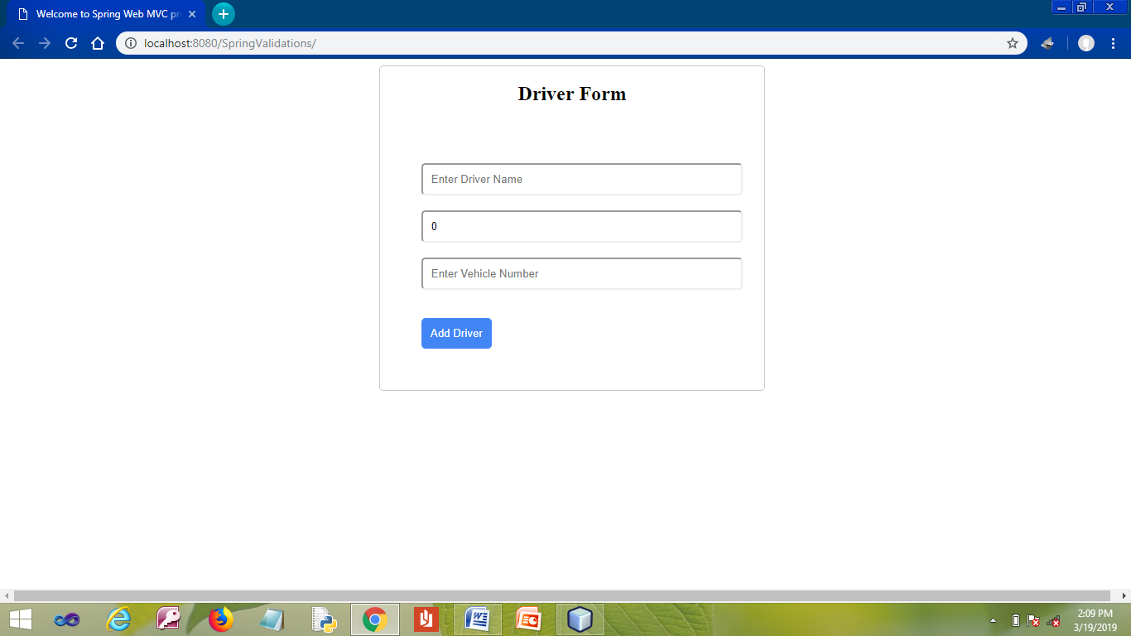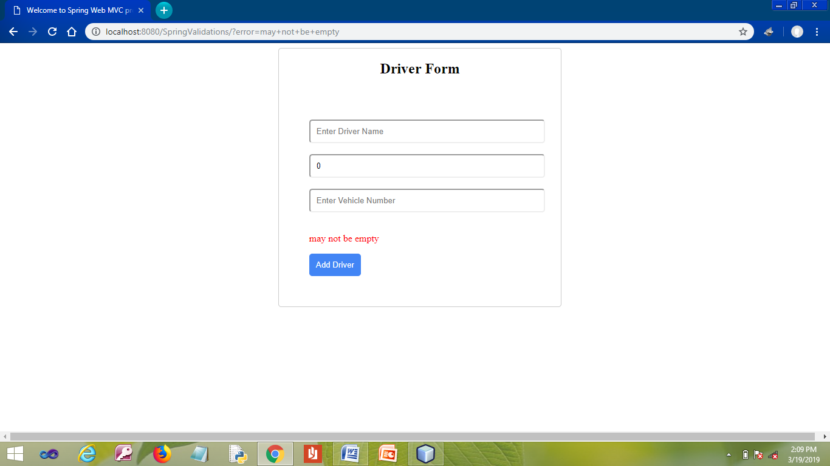

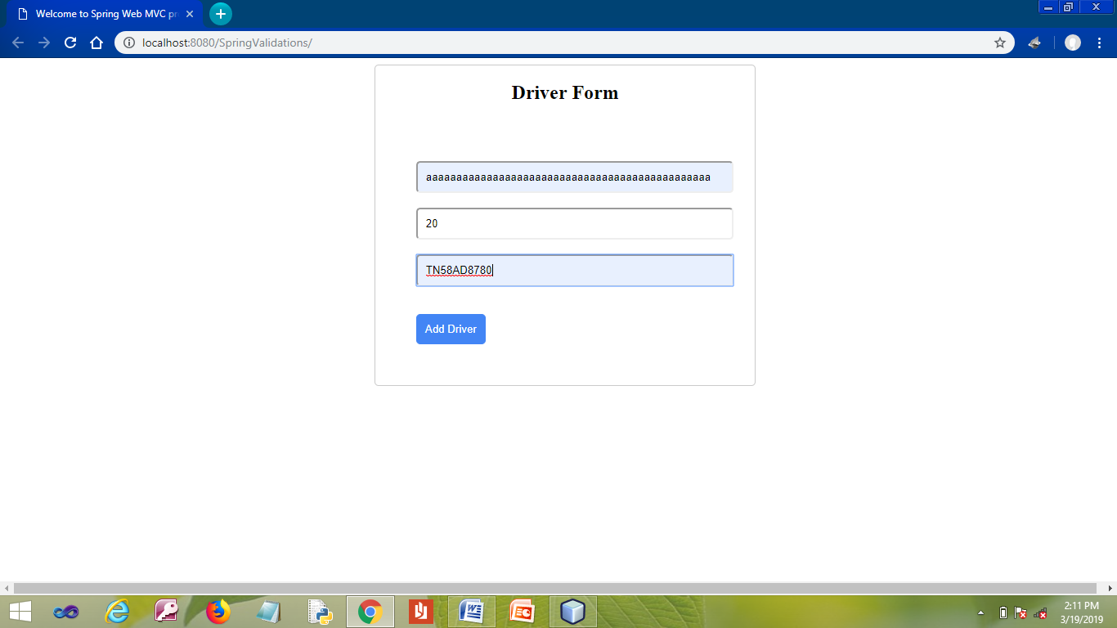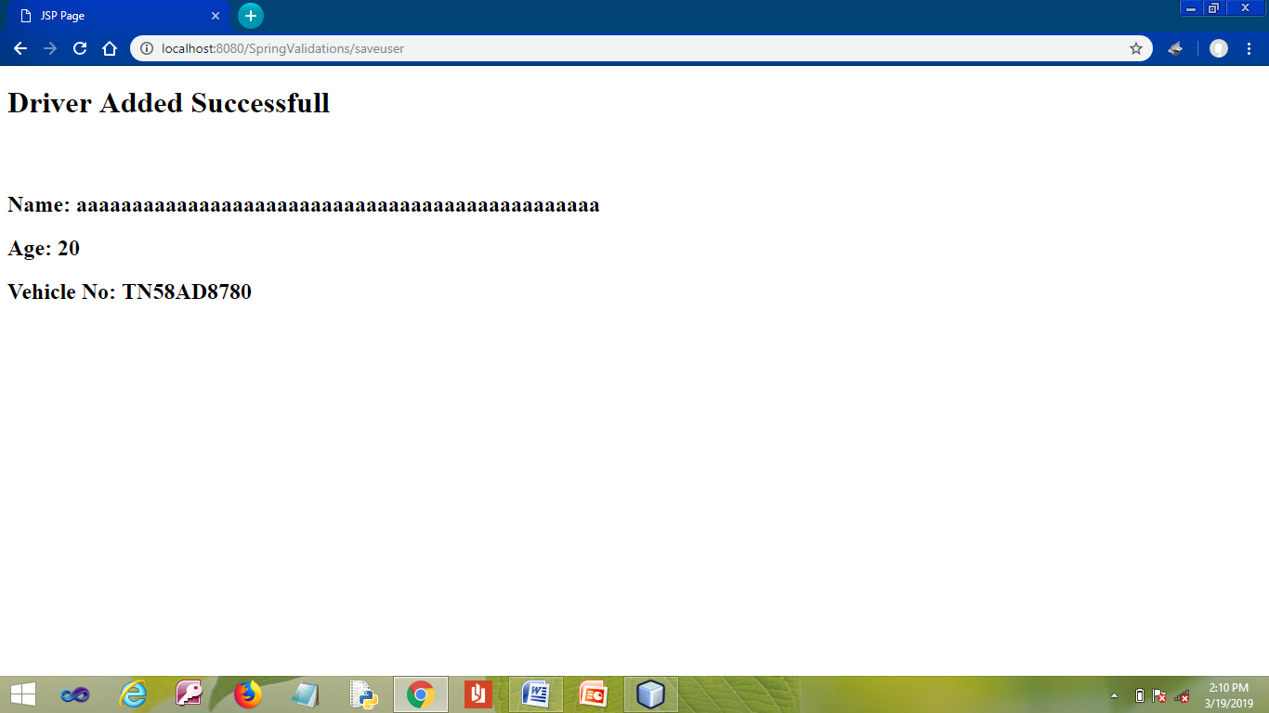

**RESULT**

Thus the program has been developed and executed successfully.

|  |  |
| --- | --- |
| EX.NO: **13** | **CRUD OPERATION USING SPRING AND JDBC**  **FOR STUDENT DETAILS** |
| DATE: |

**AIM**

To Develop a Web Application to perform CURD operation using Spring MVC and JDBC for Student Details.

**PROCEDURE**

**MYSQL**

* Open MYSQL.
* Create Database and Table.

**NETBEANS**

* Open NetBeans IDE 6.9
* Open File →New Project.
* Choose Java Web →Web Application.
* Next.
* Give the Project a Name.
* Next →Next.
* Click the Check Box **Spring Web MVC**.
* Make changes on the **Configuration** settings.
* Change Dispatcher Mapping as **/**.
* Finish.
* Write codings for the **index.jsp** File.
* Right Click on the **jsp** File.
* Select new→ JSP.
* Give the jsp file a name **(menu.jsp)**.
* Finish.
* Right Click on the **jsp** File.
* Select new→ JSP.
* Give the jsp file a name **(studentform.jsp)**.
* Finish.
* Right Click on the **jsp** File.
* Select new→ JSP.
* Give the jsp file a name **(success.jsp)**.
* Finish.
* Include two jar Files by right clicking on the Add Jar/Folder.
* Select the jar Files from C:→Program Files→NetBeans 6.9→ide→modules→ext.
  + mysql-connector-java-5.1.6-bin.jar
  + validation-api-2.0.0.Final.jar **( Download from Net )**
* Add.
* Make changes to the **dispatcher-servlet.xml**.
* Right click on the **Source Package**.
* Select new→ **Java class**.
* Give a name for the java class **( Student.java )** and the package **(springcontroller)**.
* Finish.
* Right click on the springcontroller package.
* Select new→ **Java class**.
* Give a name for the java class **( StudentController.java )**.
* Finish.
* Right click on the springcontroller package.
* Select new→ **Java class**.
* Give a name for the java class **( Jdbc.java )**.
* Finish.
* Save the Project.
* Run the Project.

**PROGRAM**

**MYSQL**

* create database **springjdbc**;
* use **springjdbc**;

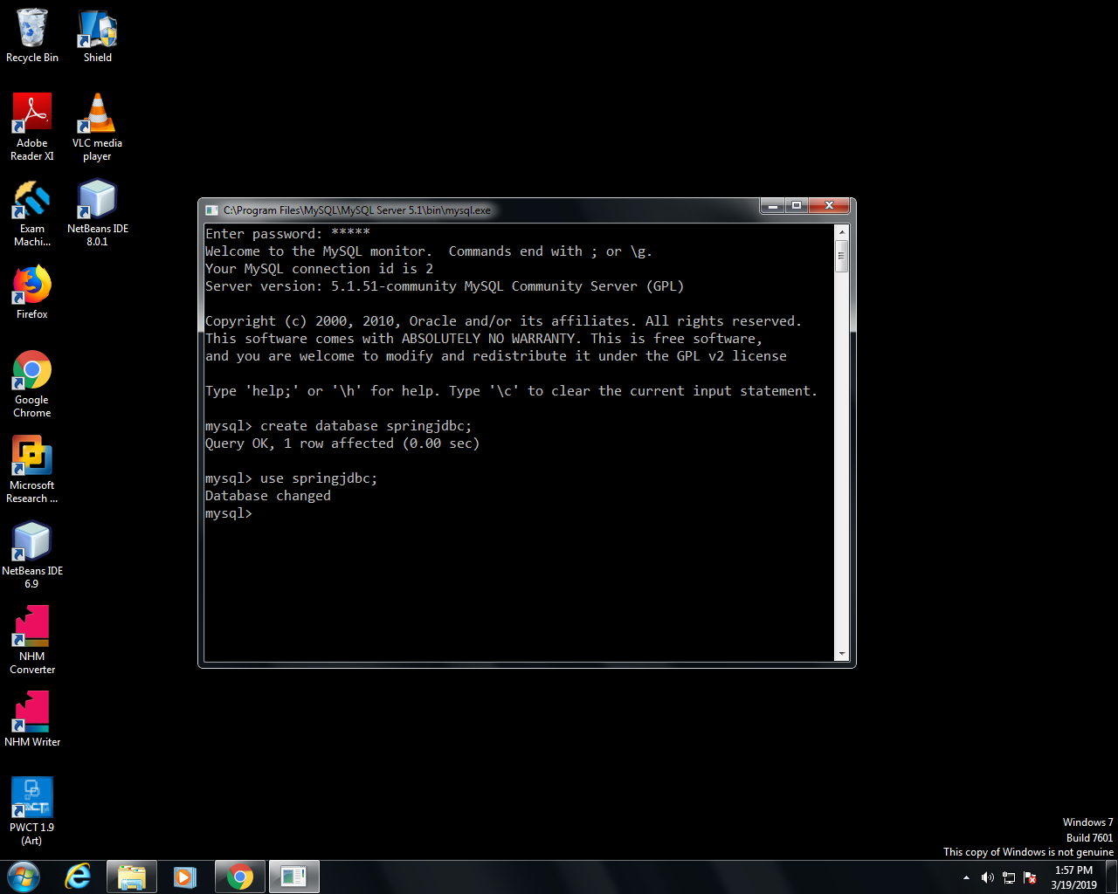

**NETBEANS**

**index.jsp**

<%@page contentType="text/html" pageEncoding="UTF-8"%>

<%@ taglib prefix = "c" uri = "http://java.sun.com/jsp/jstl/core" %>

<!DOCTYPE HTML PUBLIC "-//W3C//DTD HTML 4.01 Transitional//EN"

"http://www.w3.org/TR/html4/loose.dtd">

<html>

<head>

<meta http-equiv="Content-Type" content="text/html; charset=UTF-8">

<title>Welcome to Spring Web MVC project</title>

</head>

<body>

<h1>Student List</h1>

<table border="1px">

<thead>

<tr>

<th>Rollno</th>

<th>Name</th>

<th>Age</th>

<th>Department</th>

<th>Option</th>

</tr>

</thead>

<tbody>

<c:forEach var = "s"items="${slist}" >

<tr>

<td><c:out value = "${s.rollno}"/></td>

<td><c:out value = "${s.name}"/></td>

<td><c:out value = "${s.age}"/></td>

<td><c:out value = "${s.dept}"/></td>

<td><a href="http://localhost:8080/SpringCurd/deletestudent?rn=${s.rollno}">Delete</a></td>

</tr>

</c:forEach>

</tbody>

</table>

<%@include file="menu.jsp" %>

</body>

</html>

**success.jsp**

<%@page contentType="text/html" pageEncoding="UTF-8"%>

<!DOCTYPE html>

<html>

<head>

<meta http-equiv="Content-Type" content="text/html; charset=UTF-8">

<title>JSP Page</title>

</head>

<body>

<h1>${msg}</h1>

<br>

<%@include file="menu.jsp" %>

</body>

</html>

**menu.jsp**

<div style="display: block;">

<a href="http://localhost:8080/SpringCurd/">Home</a> |

<a href="http://localhost:8080/SpringCurd/createtable">Create Table</a> |

<a href="http://localhost:8080/SpringCurd/addstudent">Add</a> |

<a href="http://localhost:8080/SpringCurd/updatestudent">Update</a>

</div>

**studentform.jsp**

<%@page contentType="text/html" pageEncoding="UTF-8"%>

<%@taglib uri="http://www.springframework.org/tags/form" prefix="f" %>

<!DOCTYPE html>

<html>

<head>

<meta http-equiv="Content-Type" content="text/html; charset=UTF-8">

<title>Welcome to Spring Web MVC project</title>

</head>

<style>

input{

padding: 10px;

border-radius: 5px;

width: 100%;

}

button {

padding: 10px;

border-radius: 5px;

background: #4285F5;

border: 1px solid #4285F5;

color: #fff;

}

</style>

<body style="width: 100%">

<div style="margin: auto; width: 34%; border: 1px solid #cacaca; border-radius: 5px;">

<h2 style="text-align: center;">${opr} Student Form</h2>

<f:form action="http://localhost:8080/SpringCurd/${action}" method="post" style="padding: 50px;">

<f:input type="text" path="rollno" placeholder="Enter RollNo" maxlength="10"/>

<font color='red'><form:errors path='rollno' /></font>

<br>

<br>

<f:input type="text" path="name" placeholder="Enter Name" maxlength="200"/>

<font color='red'><form:errors path='name' /></font>

<br>

<br>

<input type="number" name="age" placeholder="Enter Age" maxlength="5" />

<font color='red'><form:errors path='age' /></font>

<br>

<br>

<f:input type="text" path="dept" placeholder="Enter Department" maxlength="100"/>

<font color='red'><form:errors path='dept' /></font>

<br>

<br>

<%String error = request.getParameter("error") != null ? request.getParameter("error") : "";%>

<p style="color: red;"><%=error%></p>

<button type="submit">Submit</button>

<br>

</f:form>

<%@include file="menu.jsp" %>

</div>

</body>

</html>

**dispatcher-servlet.xml**

<?xml version="1.0" encoding="UTF-8"?>

<beans xmlns="http://www.springframework.org/schema/beans"

xmlns:xsi="http://www.w3.org/2001/XMLSchema-instance" xmlns:context="http://www.springframework.org/schema/context"

xmlns:mvc="http://www.springframework.org/schema/mvc"

xsi:schemaLocation="

http://www.springframework.org/schema/beans http://www.springframework.org/schema/beans/spring-beans.xsd

http://www.springframework.org/schema/context http://www.springframework.org/schema/context/spring-context.xsd

http://www.springframework.org/schema/mvc http://www.springframework.org/schema/mvc/spring-mvc.xsd">

<mvc:annotation-driven />

<context:component-scan base-package="springcontroller" />

<context:annotation-config />

<bean id="viewResolver"

class="org.springframework.web.servlet.view.InternalResourceViewResolver">

<property name="prefix" value="/WEB-INF/jsp/" />

<property name="suffix" value=".jsp" />

</bean>

</beans>

**Student.java**

package springcontroller;

public class Student {

private String rollno, name, dept;

private int age;

public String getRollno() {

return rollno;

}

public void setRollno(String rollno) {

this.rollno = rollno;

}

public String getName() {

return name;

}

public void setName(String name) {

this.name = name;

}

public String getDept() {

return dept;

}

public void setDept(String dept) {

this.dept = dept;

}

public int getAge() {

return age;

}

public void setAge(int age) {

this.age = age; }}

**StudentController.java**

package springcontroller;

import javax.validation.Valid;

import org.springframework.stereotype.Controller;

import org.springframework.ui.ModelMap;

import org.springframework.validation.BindingResult;

import org.springframework.web.bind.annotation.ModelAttribute;

import org.springframework.web.bind.annotation.RequestMapping;

import org.springframework.web.bind.annotation.RequestMethod;

import org.springframework.web.bind.annotation.RequestParam;

import org.springframework.web.servlet.ModelAndView;

@Controller

public class StudentController {

@RequestMapping(value="/", method=RequestMethod.GET)

public String index(ModelMap map){

new Jdbc().init();

map.addAttribute("slist", new Jdbc().getStudent());

return "index";

}

@RequestMapping(value="/createtable", method=RequestMethod.GET)

public String initRecord(ModelMap map){

new Jdbc().init();

map.addAttribute("msg", "Student table created successfull");

return "success";

}

@RequestMapping(value="/addstudent", method=RequestMethod.GET)

public ModelAndView addStudent(ModelMap map){

ModelAndView mv = new ModelAndView("studentform", "command", new Student());

mv.addObject("opr", "Add");

mv.addObject("action", "addstudent");

return mv;

}

@RequestMapping(value="/addstudent", method=RequestMethod.POST)

public String addStudent(@ModelAttribute("student") @Valid Student s, BindingResult bs,ModelMap map){

bs = new Jdbc().addStudent(s, bs);

if (bs.hasErrors()) {

map.addAttribute("error", bs.getFieldError().getDefaultMessage());

return "redirect:/"; }

map.addAttribute("msg", "Student Added Successfull");

return "success";

}

@RequestMapping(value="/updatestudent", method=RequestMethod.GET)

public ModelAndView updateStudent(ModelMap map){

ModelAndView mv = new ModelAndView("studentform", "command", new Student());

mv.addObject("opr", "Update");

mv.addObject("action", "updatestudent");

return mv;

}

@RequestMapping(value="/updatestudent", method=RequestMethod.POST)

public String updateStudent(@ModelAttribute("student") @Valid Student s, BindingResult bs,ModelMap map){

bs = new Jdbc().updateStudent(s, bs);

if (bs.hasErrors()) {

map.addAttribute("error", bs.getFieldError().getDefaultMessage());

return "redirect:/updatestudent";

}

map.addAttribute("msg", "Student Updated Successfull");

return "success";

}

@RequestMapping(value="/deletestudent", method = RequestMethod.GET)

public String deleteStudent(ModelMap map,

@RequestParam(required = true, defaultValue = "1", value="rn") String rn){

new Jdbc().deleteStudent(rn);

map.addAttribute("msg", "Student Deleted Successfull "+rn);

return "success";

}

}

**Jdbc.java**

package springcontroller;

import java.sql.ResultSet;

import java.sql.SQLException;

import java.util.List;

import org.springframework.jdbc.core.JdbcTemplate;

import org.springframework.jdbc.core.RowMapper;

import org.springframework.jdbc.datasource.DriverManagerDataSource;

import org.springframework.validation.BindingResult;

public class Jdbc {

private JdbcTemplate db;

public Jdbc() {

DriverManagerDataSource ds = new DriverManagerDataSource();

ds.setDriverClassName("com.mysql.jdbc.Driver");

ds.setUrl("jdbc:mysql://localhost:3306/springjdbc");

ds.setUsername("root");

ds.setPassword("mysql");

this.db = new JdbcTemplate(ds);

}

public JdbcTemplate getDb() {

return db;

}

public void init(){

db.execute("CREATE TABLE IF NOT EXISTS student(rollno varchar(10), name varchar(255), age int(5), "

+ "dept varchar(255));");

}

public BindingResult addStudent(Student s, BindingResult bs){

db.update("insert into student values(?,?,?,?)", s.getRollno()

, s.getName(), s.getAge(), s.getDept());

return bs;

}

public BindingResult updateStudent(Student s, BindingResult bs){

db.update("update student set name=?, age=?, dept=? where rollno=?"

, s.getName(), s.getAge(), s.getDept(), s.getRollno());

return bs;

}

public void deleteStudent(String rollno){

db.update("delete from student where rollno=?", rollno);

}

public List<Student> getStudent(){

List<Student> slist = db.query("select * from student", new RowMapper<Student>() {

@Override

public Student mapRow(ResultSet rs, int i) throws SQLException {

Student s = new Student();

s.setRollno(rs.getString("rollno"));

s.setName(rs.getString("name"));

s.setAge(rs.getInt("age"));

s.setDept(rs.getString("dept"));

System.out.println(s.getName());

return s;

}

});

return slist;

}

}

**OUTPUT**

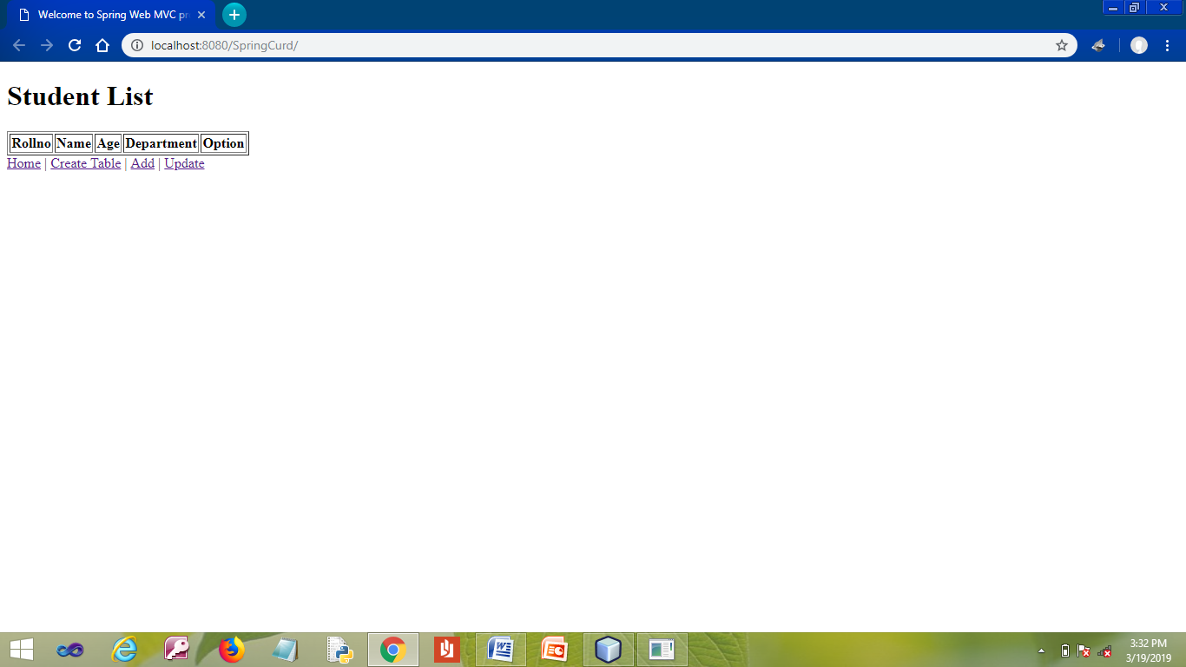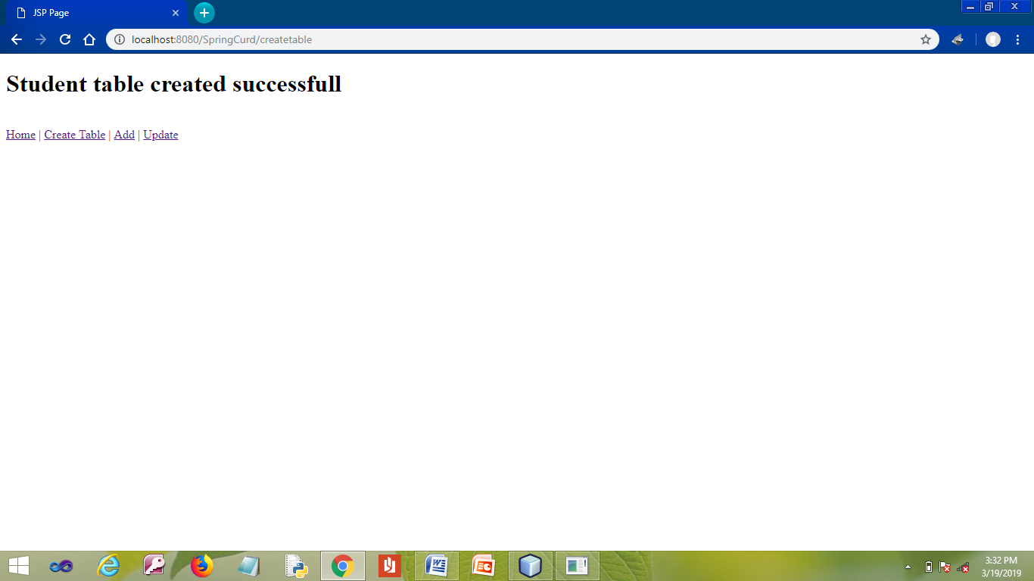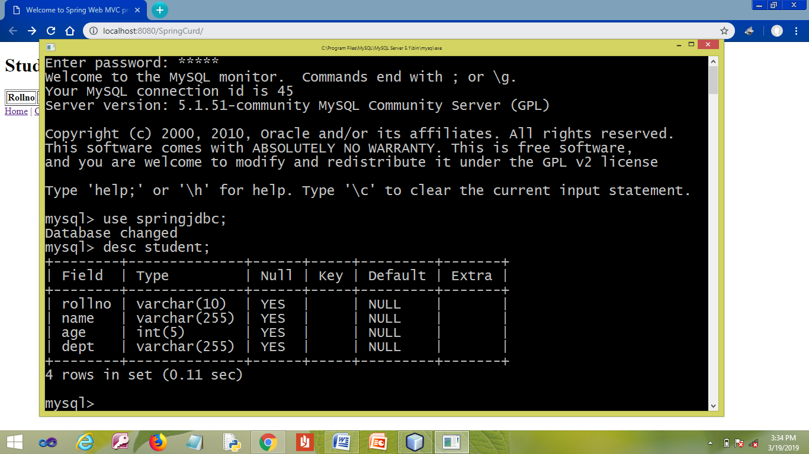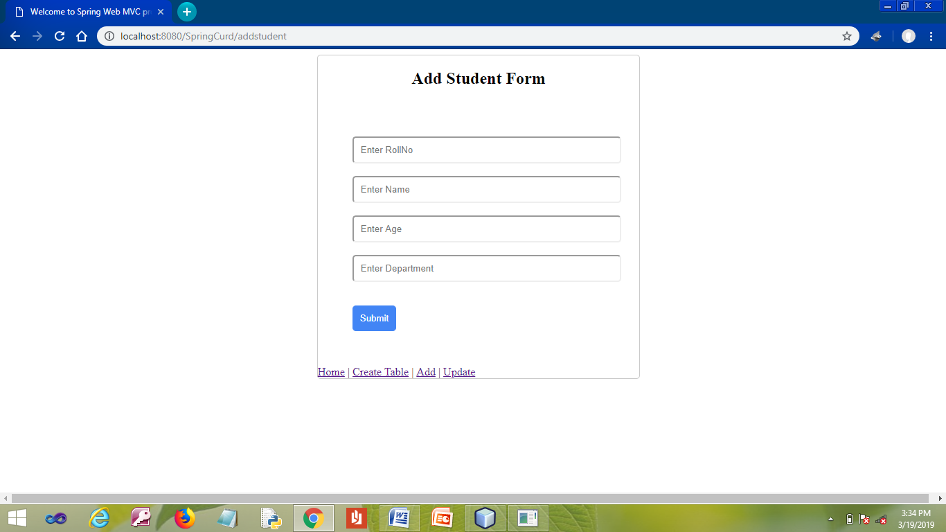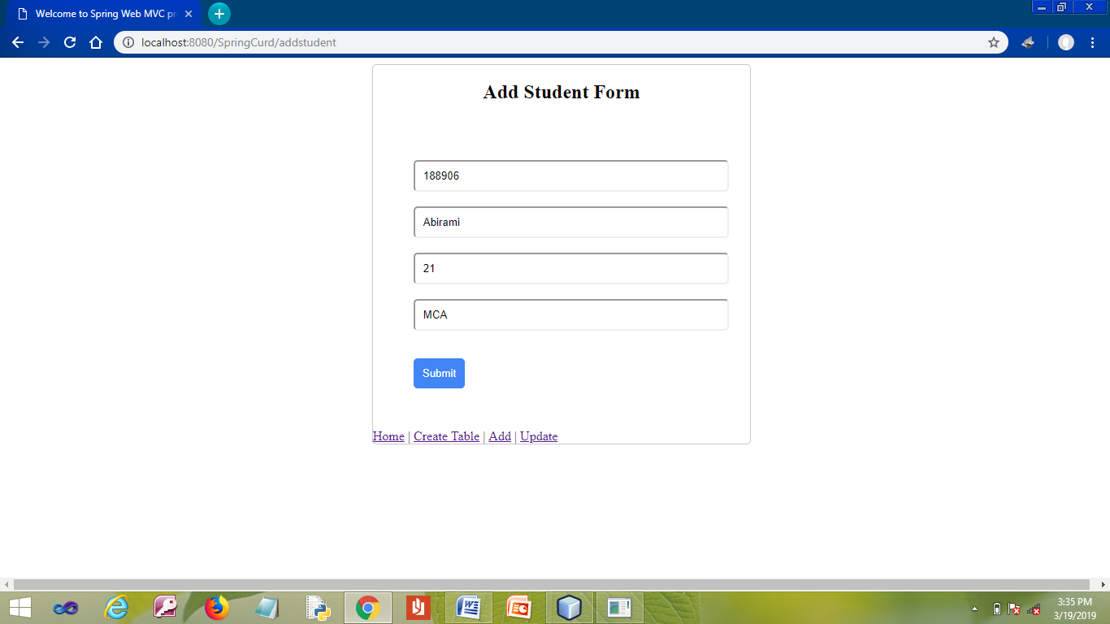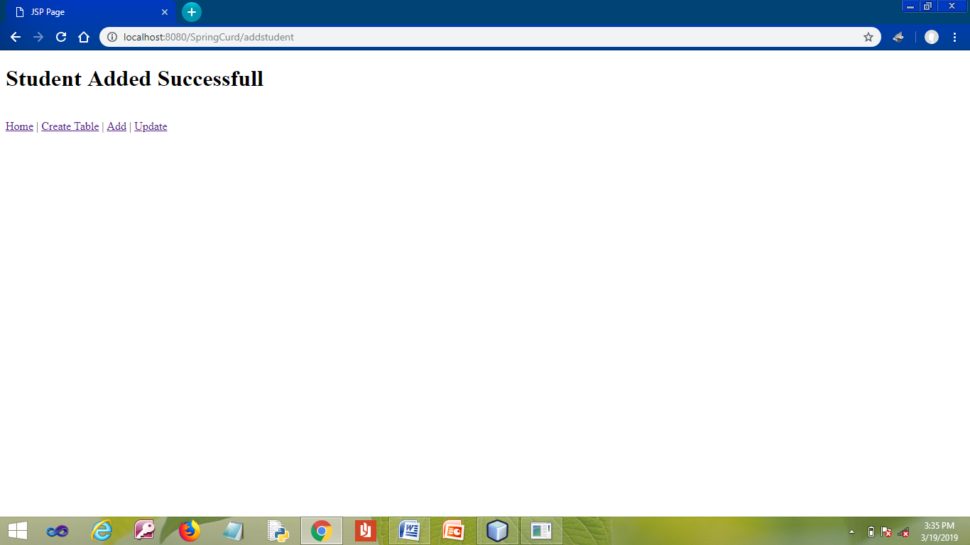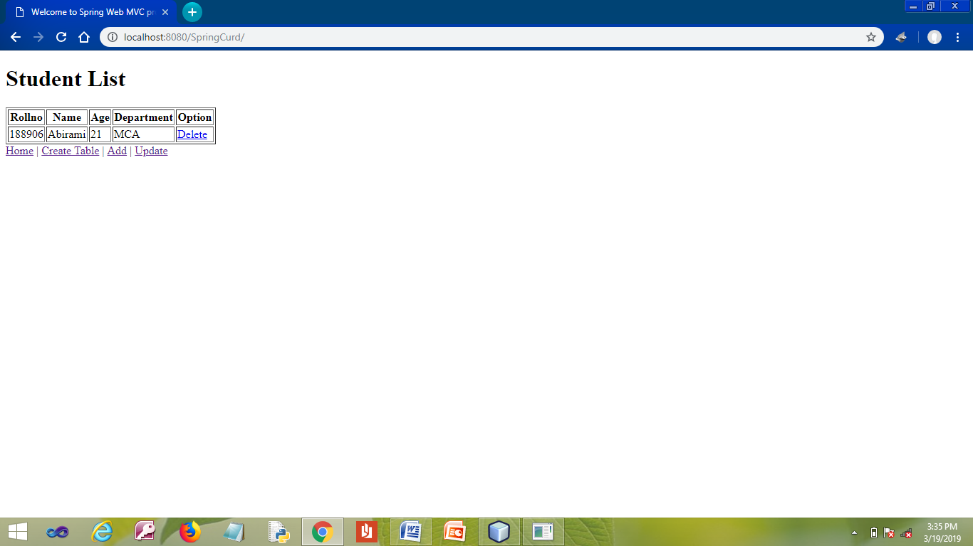

**RESULT**

Thus the program has been developed and executed successfully.